PSM 备份

1 Master Python programming fundamentals, such as variables, data types, loops, functions, and conditional statements;

2 Discover how to use Jupyter Notebook for developing, presenting, and sharing data science projects;

3 Leverage key Python libraries, such as pandas for data wrangling and analysis, Matplotlib and Seaborn for data visualization, and Plotly Express for interactive data visualization in a financial context;

4 Perform portfolio optimization, run Monte Carlo simulations, and calculate portfolio returns, risks, and Sharpe ratios in Python; and

Obtain real-world financial data using pandas Datareader and Yahoo! Finance API in Python.

Environment setup and jupyter notebook walk through

Environment(saturn cloud) overview, Jupyter Notebook walkthrough

### LESSON 1.1 VARIABLES ASSIGNMENT, MATH OPERATIONS AND DATA TYPES

In this unit, you will learn to:

Define Python variables, assign values to them, and perform math operations;

Discern the differences among various data types in Python, such as integers, floating points, and Booleans;

Leverage the Python print() function to display a message to the screen;

Handle complex string formatting using Python’s string format() method;

Use the Python built-in input() function to get data from the user via the keyboard; and

Develop a Python application that can take data from the user, analyze it, and display a message to the screen.

First, we start by introducing a new concept, and we include them in a form of slides

Assume that you have $5,000 in your brokerage account, and you decide to invest the entire amount in Procter & Gamble (P&G) stock, which is trading at $142.5 per share. Complete the following tasks:

Write some Python code that defines two variables for the account balance and P&G stock price. Feel free to select any valid variable names.

Confirm variable data types.

Calculate number of shares that you can buy with the available balance in your account

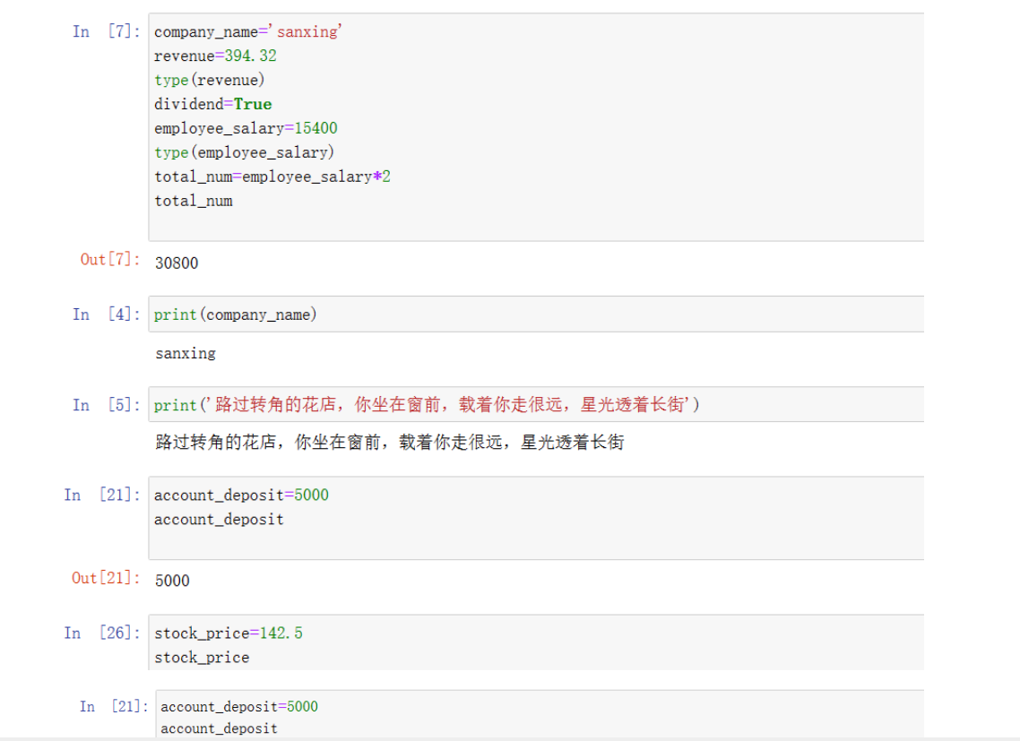

### 1.2 PRINT OPERATIONS

Write some Python code that prints the following message to the screen:

“Procter and Gamble (P&G), which reports using US GAAP, sold a piece of land for $500000”

1、Leverage Python print() function to display a message to the screen.

2、Handle complex string formatting using Python’s string format() method.

3、Print general print statements to the screen

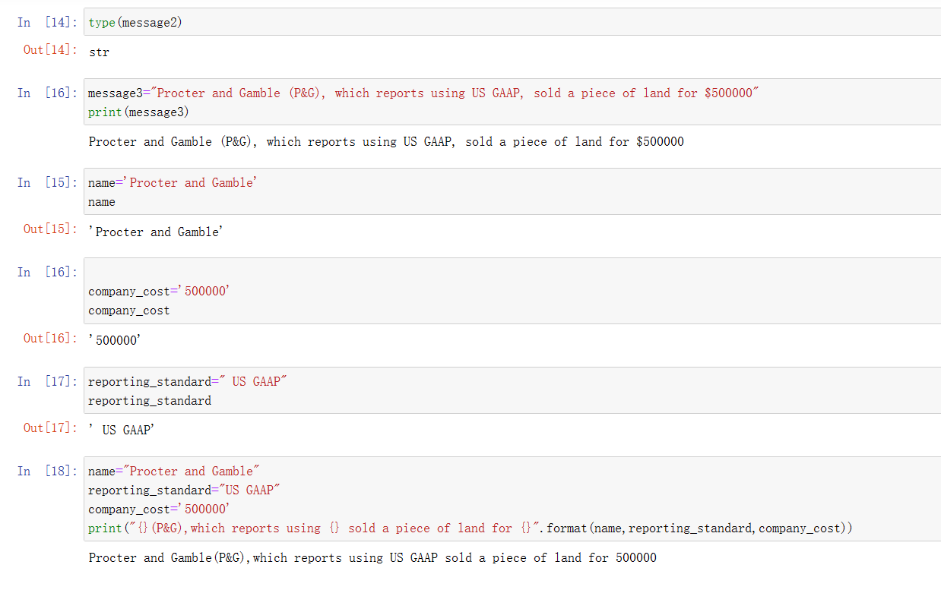

### 1.3 GET USER INPUT

Use Python’s built-in input() function to get data from the user via the keyboard.

Develop a simple application that can take data from the user, analyze the data, and display a message to the screen.

Perform type casting by changing a variable from one data type to another.

Now that you have learned how to get input from the user and store it in a variable, try the following practice opportunity.

Assume that you work as a financial analyst and have been tasked with developing a Python application that analyzes securities using the capital asset pricing model (CAPM).

Review the concept of CAPM, and write down the formula.

Write some Python code that will receive beta for a given stock, the risk-free rate, and expected broad market return from the user and will print out the expected return on the stock. Round your answer to two decimal points.

Using the CAPM formula, the expected return on Apple stock = 6.0%

CAPM 公式 E(R)=Rf+β *（Rm）



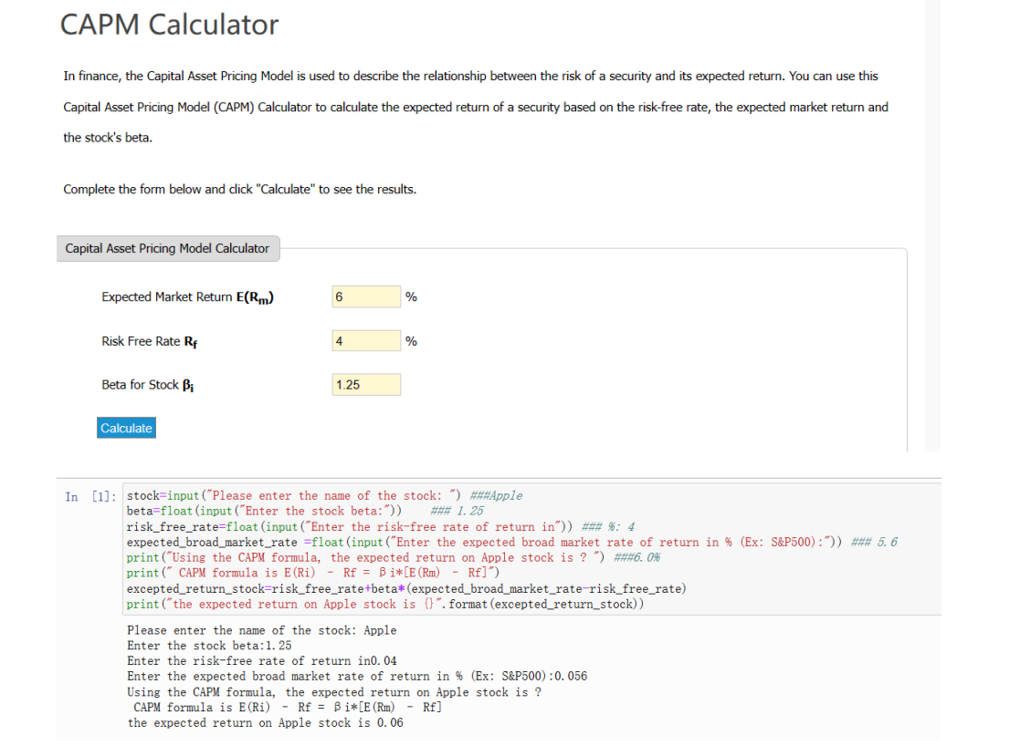

Capm indicates that the expected return on a security is equal to the risk-free plus a risk premium

Capm表示证券的预期回报等于无风险加上风险溢价

Beta is a measure of the volatility of a security compared to the broad market(S&P 500)贝塔是衡量一种证券相对于大盘（标准普尔500指数）波动性的指标

Beta =1 stock price activity is strongly correlated with the market 股票的波动与市场强相关

Beta <1 stock is less volatile than market(Ex: utility & consumer goods (P&G))

Beta>1 stock is more volatile than the market(ex: Nvidia) 股票的波动比市场大

已知：stock standard deviation 30% market standard deviation 15% ρ=0.6

求 β 0.6*（30%➗15%） =1.2

Market value beta

Asset I 3.5 1.4

Asset II 7.5 1.8

银行存款 1 0

Free risk return 1.5%

求 β 的一个例子 所有的β 加权平均

（1.4*3.5/12）+1.8*（7.5/12）+（1/12*0）=1.53

0.40833+1.125=1.53

### Lesson 2.1 - Python Lists

In this lesson, you will learn to:

Define Python lists and understand their benefits and use cases,

Use indexing to access specific elements in Python lists, and

Perform list slicing to access a range of elements within the list.

List slicing is used to obtain more than one element from a list,The slicing operator[n:m] is used to obtain elements starting with index n up to but not including the element in index m

Assume that you work as a financial analyst and you decide to list nine dividend-paying companies in the United States in a Python list named “dividend_companies” as shown:

dividend_companies = [

'Pioneer Natural Resources Co. (ticker: PXD)',

'Lumen Technologies Inc. (LUMN)',

'Altria Group Inc. (MO)',

'Vornado Realty Trust (VNO)',

'Devon Energy Corp. (DVN)',

'AT&T Inc. (T)',

'Simon Property Group Inc. (SPG)',

'Verizon Communications Inc. (VZ)',

'Kinder Morgan Inc. (KMI)']

Print the first, second, and fourth elements individually:

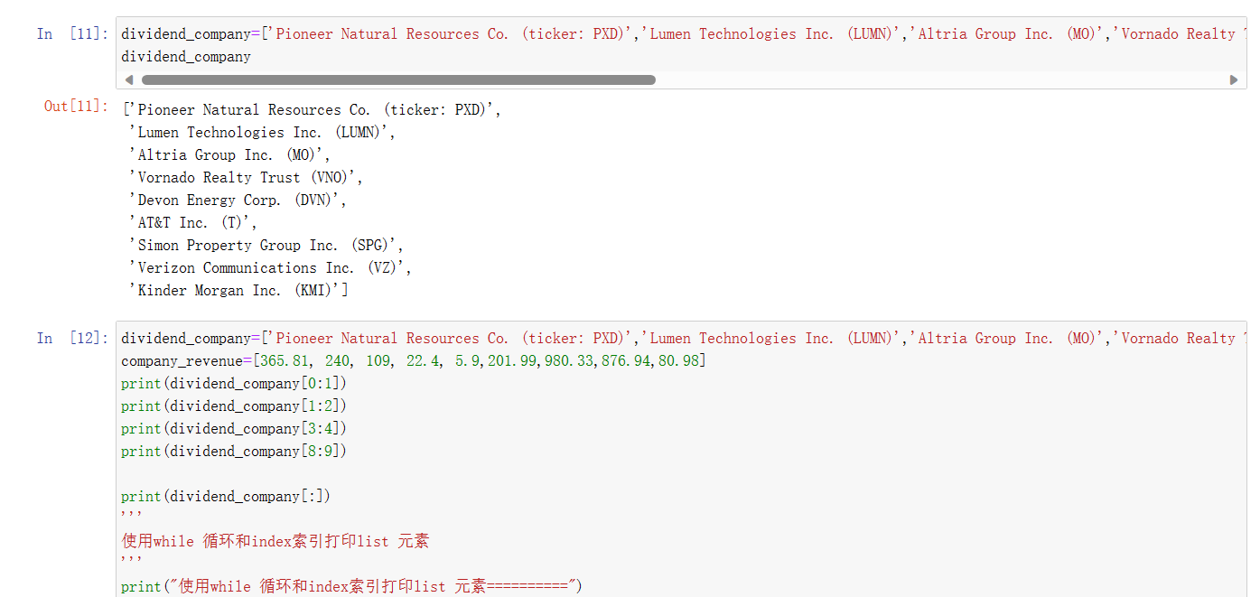

Print the last element using three different methods. (External research is required.)

Print (1) all elements in the list, (2) the first three elements, and (3) the last three elements.

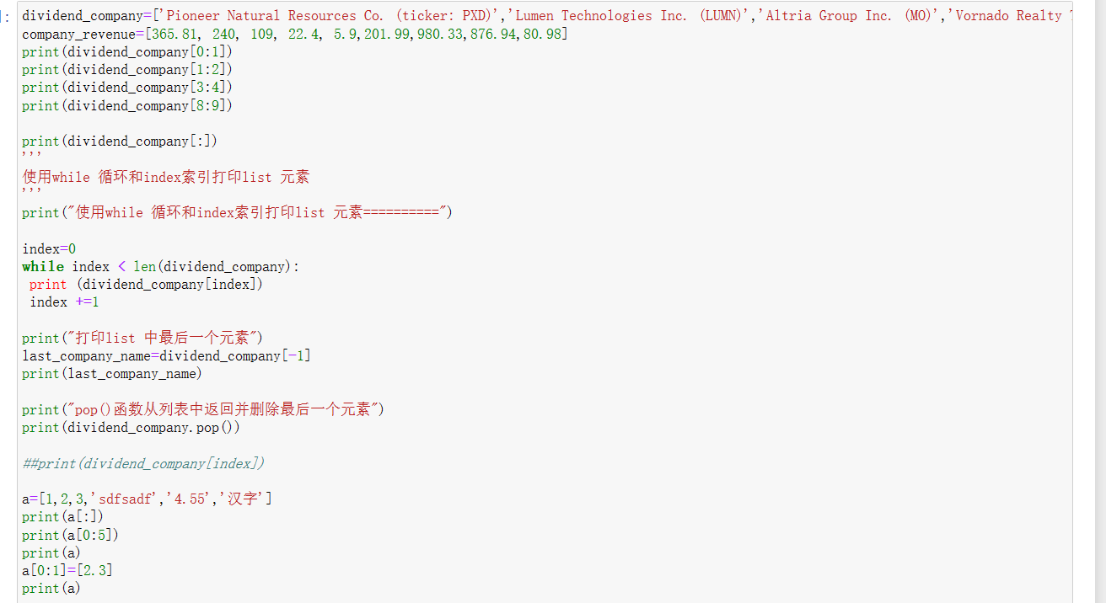

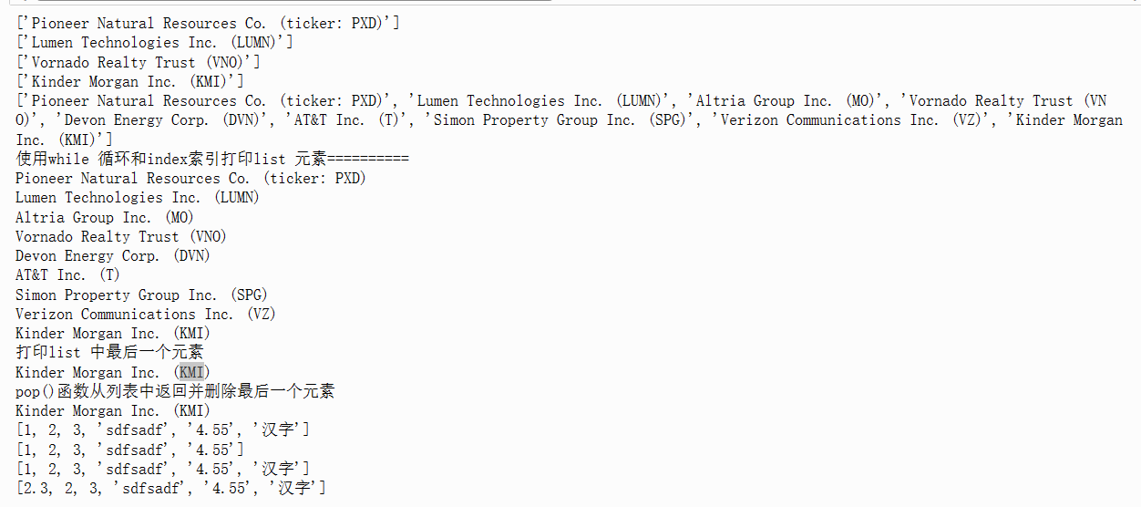

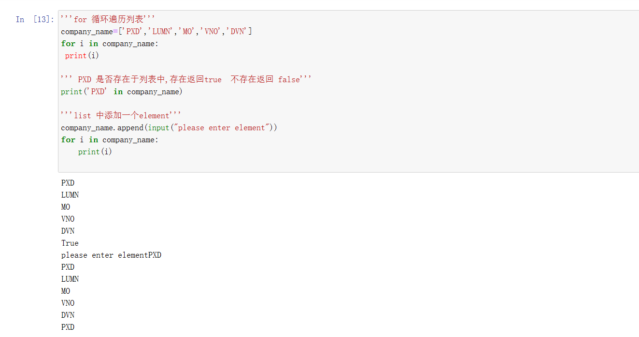

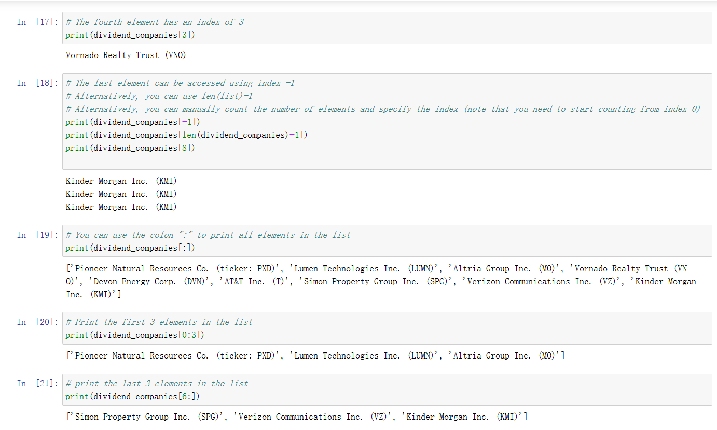

### Lesson 2.2 - Python Dictionaries

Python dictionaries 字典

Python dicitionaries consist of a collection of ske value pairs that are unordered无序的

Dictionary elements are accessed using their keys

Keys are unique while values are not 键是唯一的，而值不是

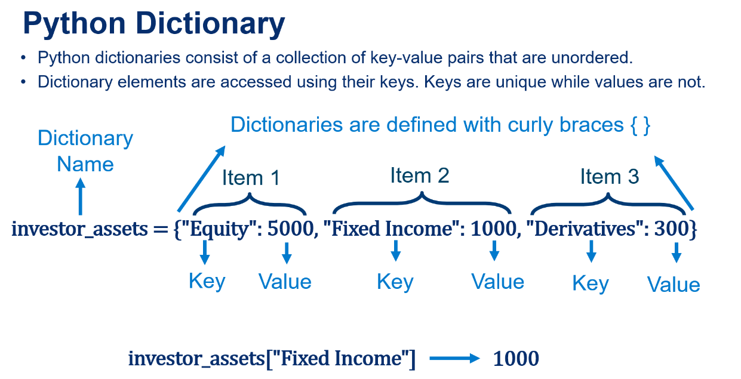

Let's define a dictionary for a given investor

# The dictionary consists of a collection of equity, fixed income and alternative investments

# Remember:

# 1. Equity: Equity investments allow investors to hold partial ownership of companies in form of stocks

# 2. Fixed income: fixed-income securities such as bonds yield fixed amounts of cash flows at given dates

# 3. Derivatives: derivative is a security with a price derived from an underlying assets such as options

# 4. Alternative investments: Non-traditional investments such as real-estate and commodities

Calculate the average stock price in this dictionary.

Now add two more stocks to the dictionary, update the dictionary, and calculate the new average using two different methods. (External research is required.)

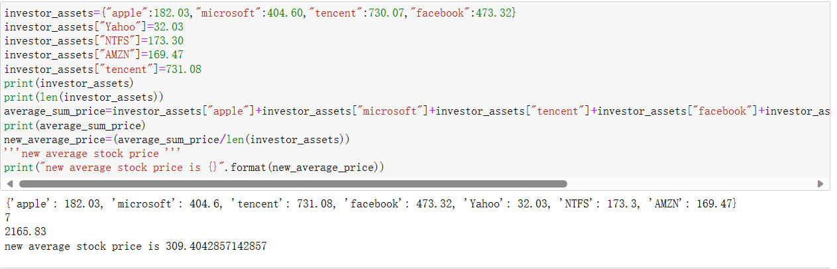

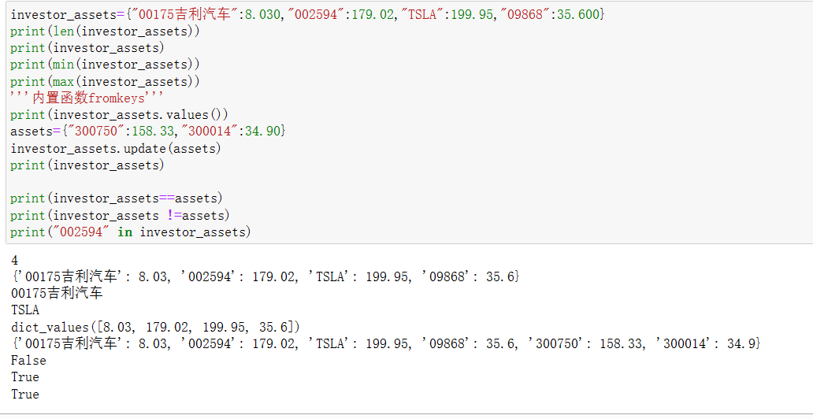

### Lesson 2.3 - Python Strings

In this lesson, you will learn to

Define Python strings and understand their use case,Concatenate two or more strings together, and Apply string methods, such as .split() to split strings into a series of words and .upper() to convert strings from lowercase to uppercase.

Assume that you work at a bank and you have been tasked with developing a Python code to obtain client feedback. Write a Python code that performs the following tasks:

Then try the following:

Test your code using three different user inputs.

Expand your code to request the user to enter their **email address.** The code should prompt clients to enter their email and then extract the user’s first name only. (Note that the email format is as follows: [firstname.lastname@gmail.com.)](mailto:firstname.lastname@gmail.com.))

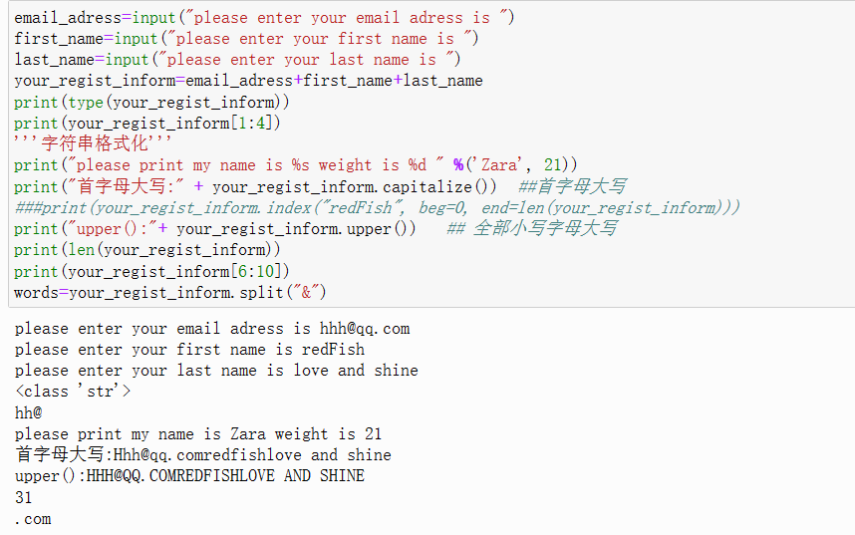

### Lesson 2.4 - Comparison Operators

Assignment operators assign a value to a variable, whereas comparison operators compare two values and return True or False. Please note that comparison operators are very useful when dealing with if-else statements and while loops (covered in later lessons).

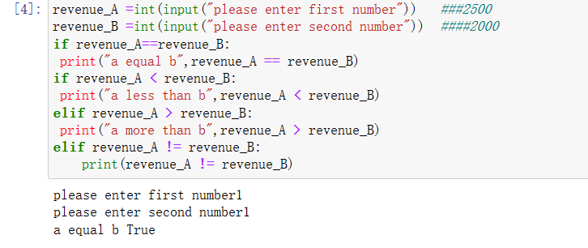

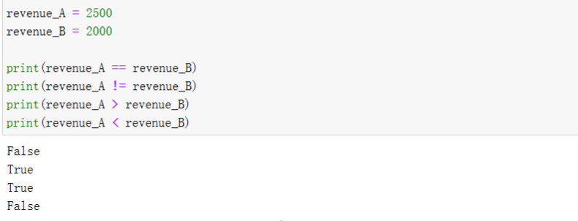

### Lesson 2.5 - Conditional Statements

Conditional statements, also known as if-else statements, contain a body of code that runs only when the condition in the if statement is true. If the condition is false, the else statement will be executed.

Understand conditional, or if-else, statements in Python,Develop a simple password authentication application, and Develop a Python application that can evaluate stocks and indicate whether they’re overvalued, fairly valued, or undervalued.

Consider a company, XYZ Inc., whose stock is currently trading at $64 per share. The company requires a 14% minimum rate of return (r) and pays a dividend of $2 dividend per share this year (D0), which is expected to increase by 10% annually (g).

Review the dividend discount model, and write down the formula. Calculate the intrinsic value (P) of the stock.

Expand the code so users can enter the current stock price, minimum rate of return, current dividend, and annual growth and print out the recommendation to the screen.

Sample code output:

V0 = D1 /（1 + r)1 + ⋯ +Dn /(1 + r)n +Pn /(1 + r)n

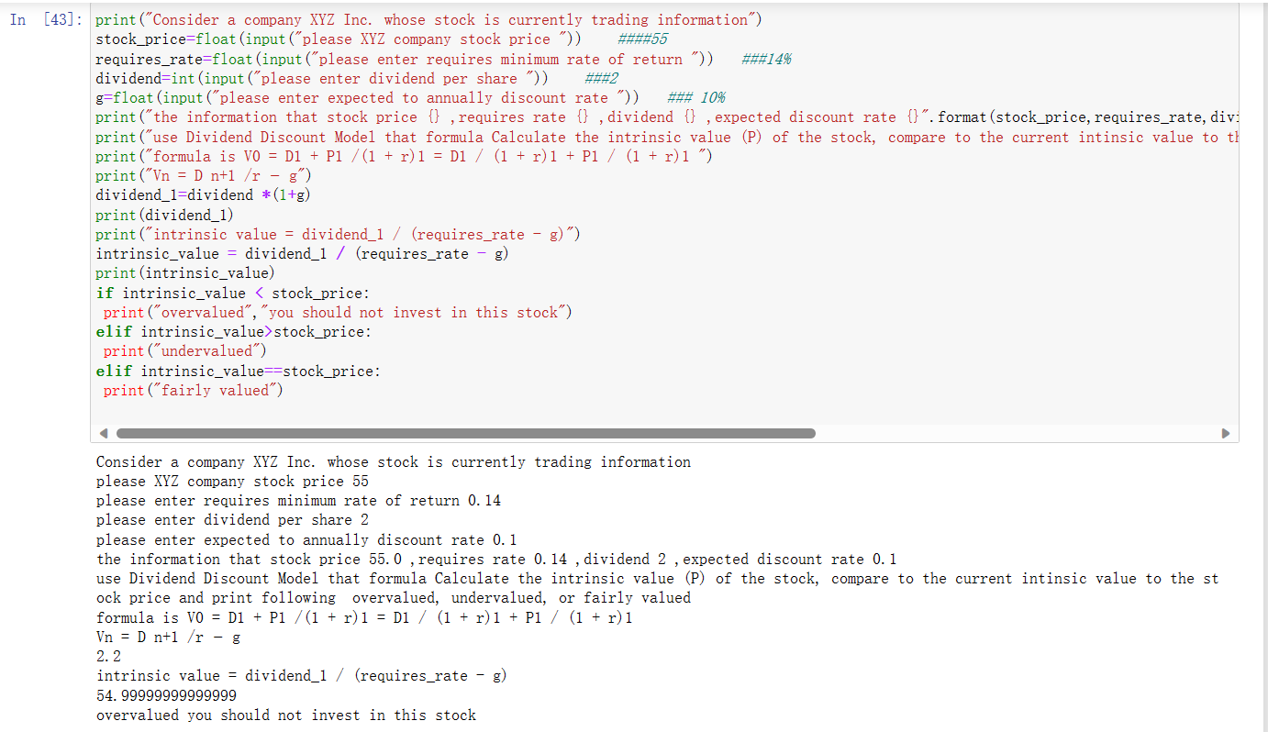

### Lesson 3.1 - “For” Loops

Write some Python code that performs the following tasks:

Defines a list named “my_list” that contains the following values: 10, 5, 3.

Multiplies all elements in the list using "for" loops.

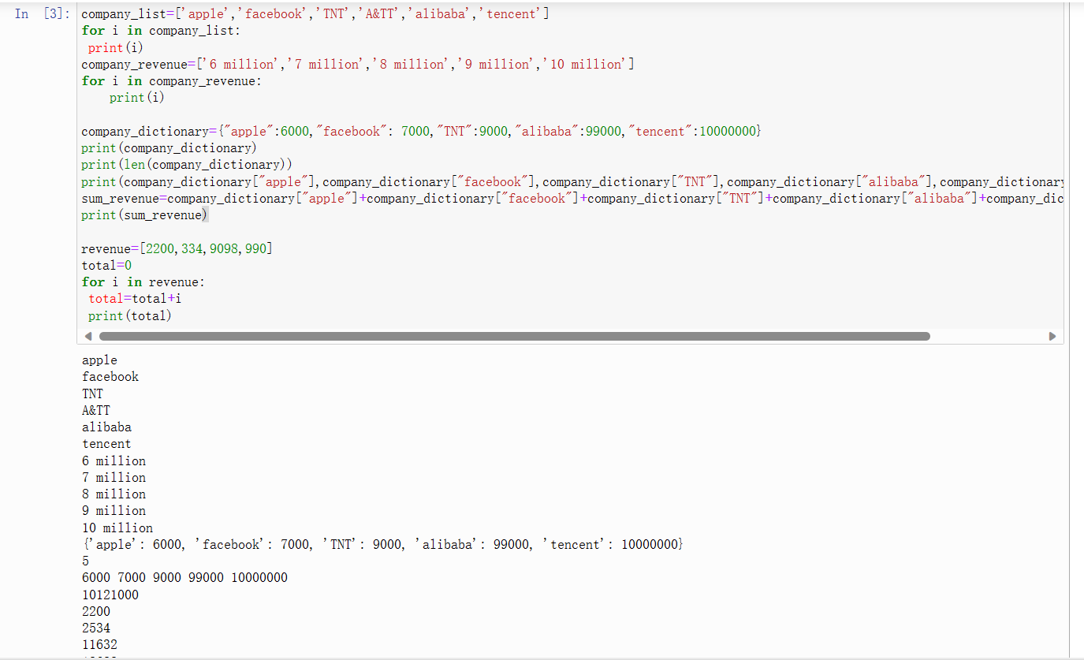

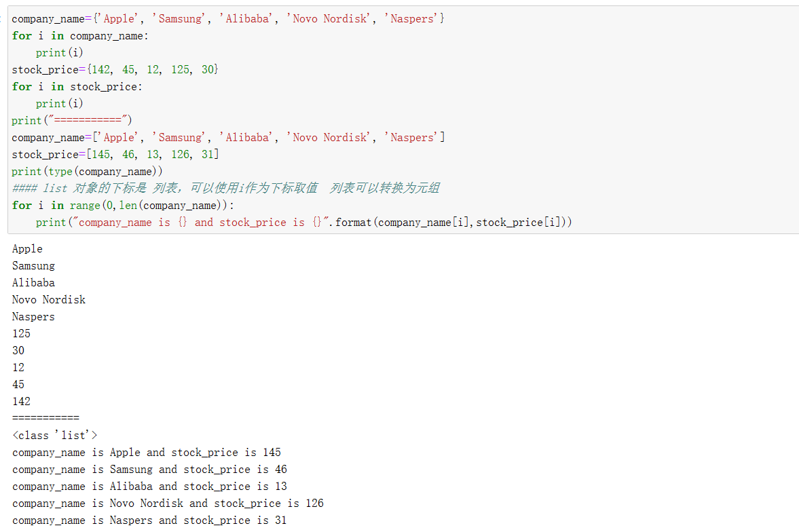

### Lesson 3.2 - Python Range() Function

The range() function generates a sequence of numbers that starts with 0 by default, increases by increments of 1, and stops before a specified number.

For example, if I say range(5), the function will generate a sequence of numbers from 0 to (but not including) 5, so: 0, 1, 2, 3, and 4.

The range() function works well with "for" loops. Because range() generates a list of numbers, we iterate over them using "for" loops.

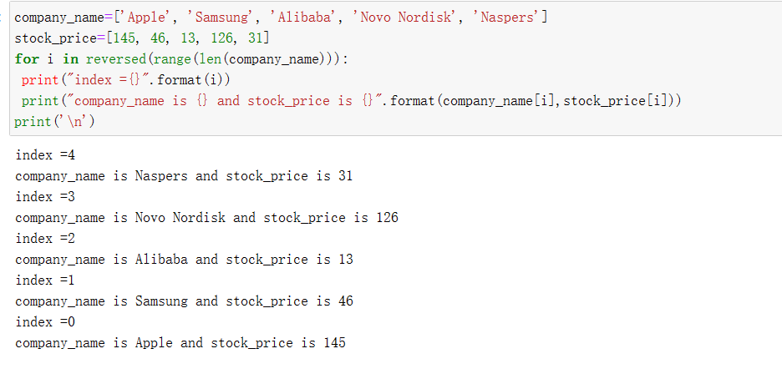

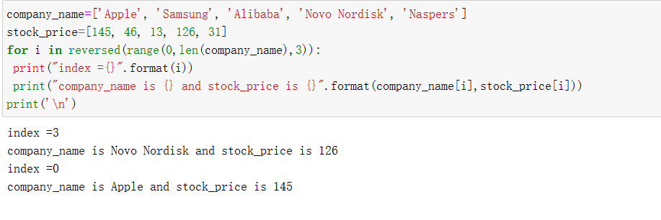

### Lesson 3.3 - “While” Loops

Write some Python code that performs the following tasks:

Takes in the present value, annual interest rate, and expected future value from the user.

Calculates the total number of years it would take to reach a given expected future value, rounds your answer to the nearest year, and prints it to the screen.

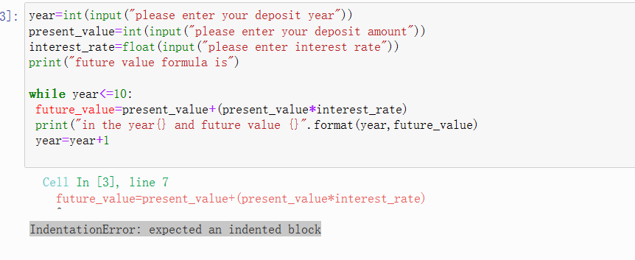

应为缩进的块

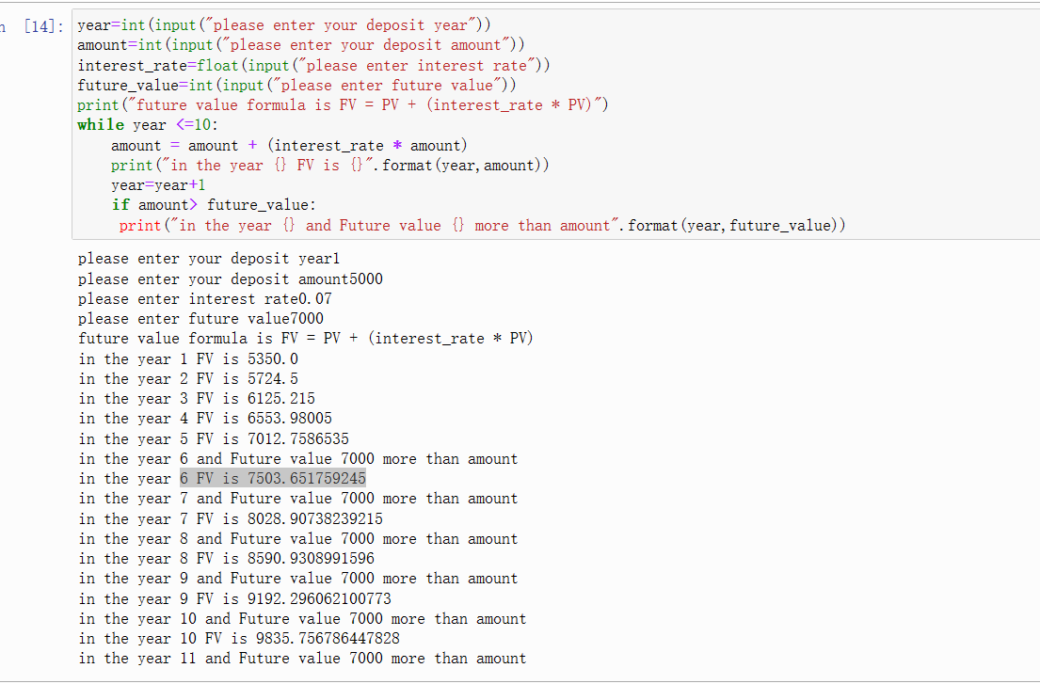

### Lesson 3.4 - Functions

Now that you have learned to harness the power of functions in Python, try the following practice opportunity.

Assume that you have been tasked to develop a Python function that calculates the effective annual rate (EAR) of return. EAR considers the effect of compounding within the year and can be calculated from the nominal (or stated) annual rate of return (𝑖) using the following formula:

EAR = (1 +i/m)m次方– 1,

where represents the number of compounding periods per year.

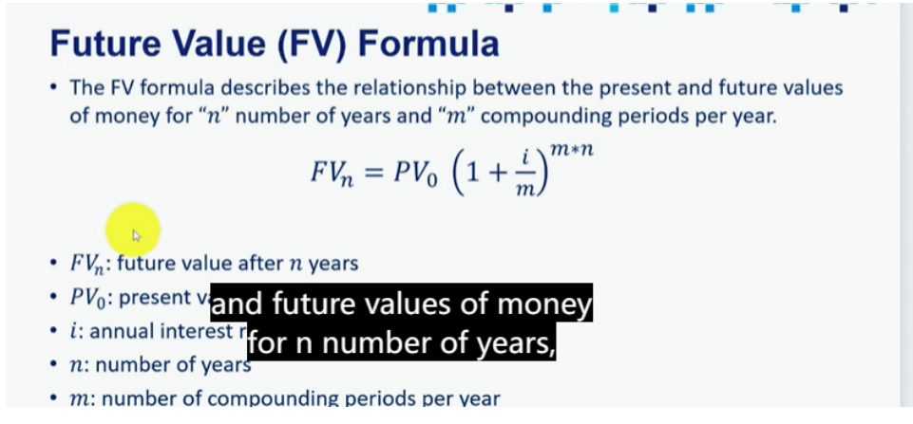

Define a Python function that calculates the effective annual rate of return. The function should receive the nominal (stated) annual rate and the number of compounding periods per year.

Assume that you deposited $1,000 today into an account paying 10% compounded quarterly. Calculate the effective annual rate of return using the function defined in Task 1. Round your answer to four decimal places.

Calculate the amount of interest you would have earned by the end of the year. Round your answer to four decimal places.

Repeat Tasks 2 and 3, but with interest compounded monthly.

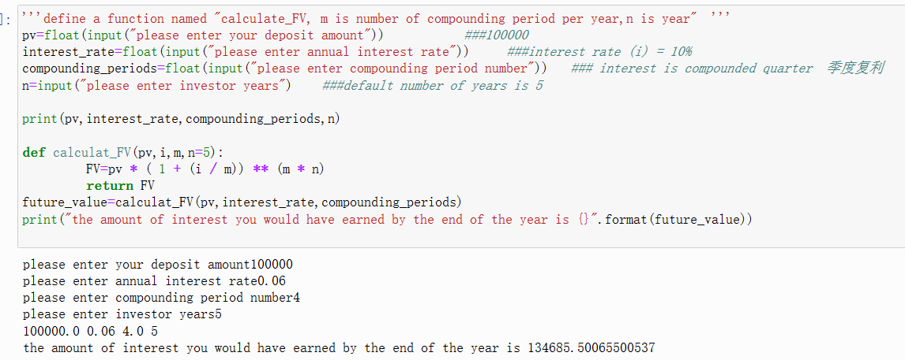

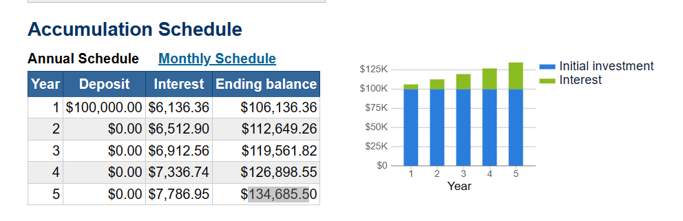

大于之前的10%的年华回报。

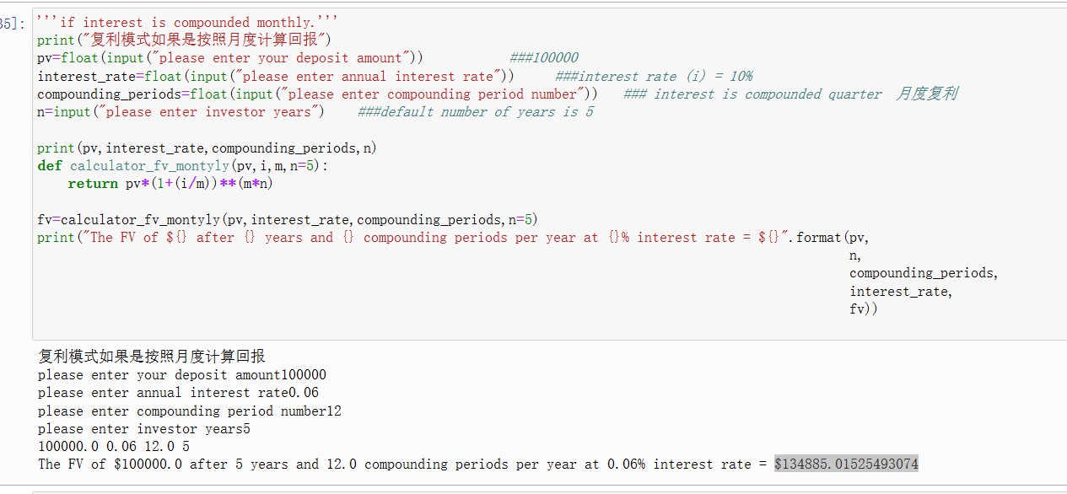

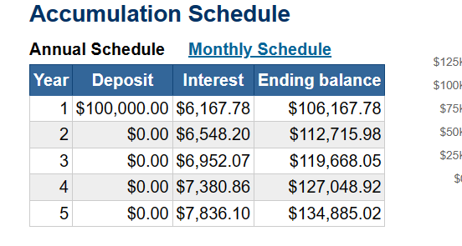

### Lesson 3.5 - Python Built-In Functions

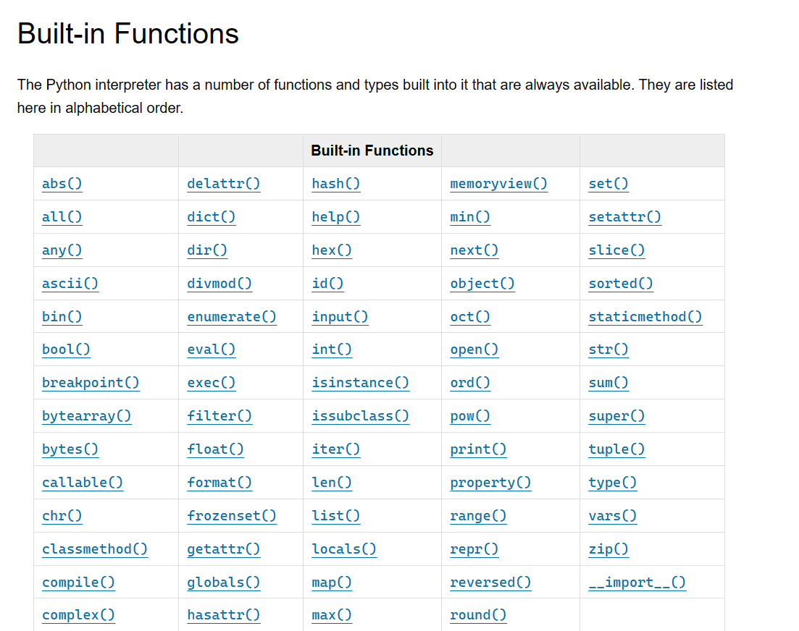

## **[Unit 4: Python Programming Fundamentals Part 4](https://www.cfainstitute.org/programs/cfa/python-programming-fundamentals" \l "92bd58a227b24aea8a75e00056bf0ee2)**

### 4.1Pandas.DataFrame

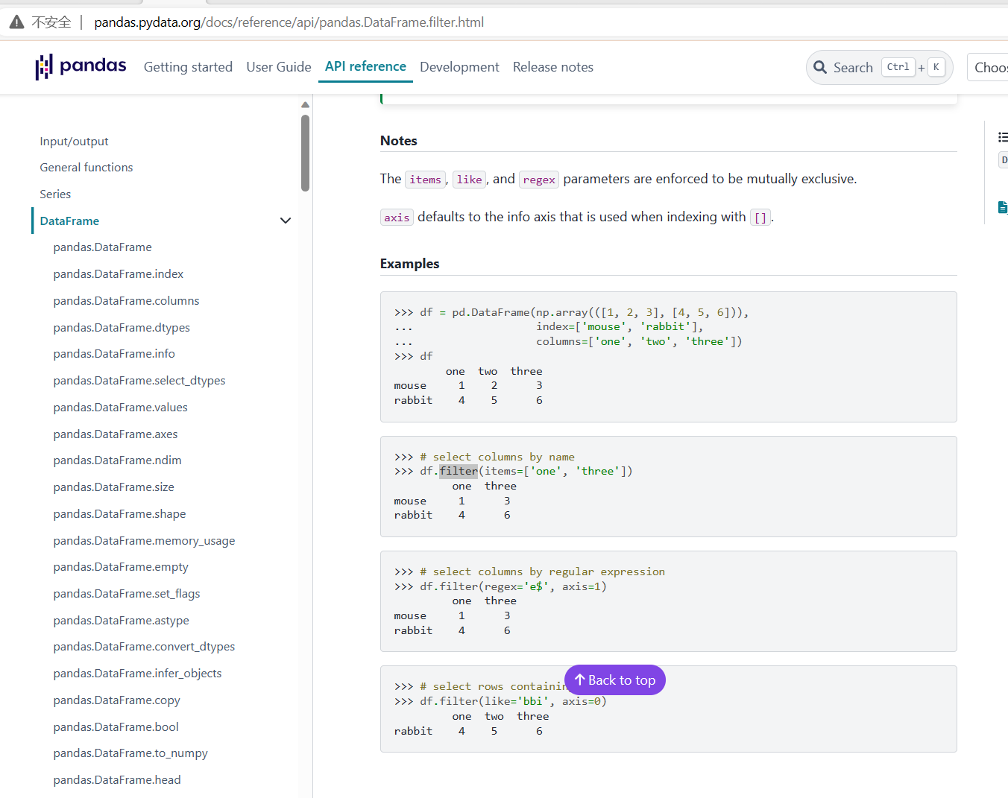

* Define two-dimensional 二维的Pandas DataFrames and obtain their statistical summary.
* Handle missing data in Pandas DataFrames and filter them out based on a specific condition.
* Define Python functions and apply them along an axis in a Pandas DataFrame.
* Perform DataFrame concatenation and merging.
* Use they finance library to obtain financial market data, such as stock prices, beta, earnings per share (EPS), balance sheets, and income statements.
* Leverage available methods to display stocks’ paid dividends, stock splits, and analysts’ ratings and recommendations.

### Lesson 4.1 - Introduction to Data Analysis with pandas

A portfolio consists of a collection of assets owned by an investor, such as stocks, bonds, real estate, and exchange-traded funds (ETFs). Using pandas DataFrames, complete the following tasks:

Define a pandas DataFrame named “portfolio_df” that holds five different stock, bond, or ETF names; ticker symbols; price per share; and number of shares. (Feel free to choose any stock, bond, or ETF and number you prefer.)

Obtain a statistical summary of the “portfolio_df” DataFrame.

Calculate the total value of the portfolio, including all assets.

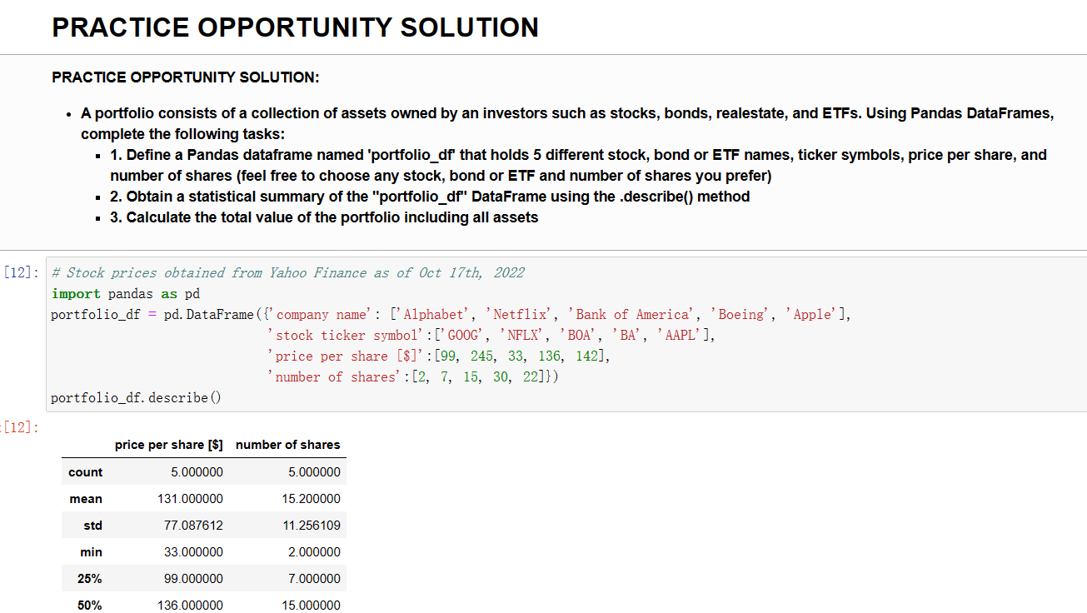

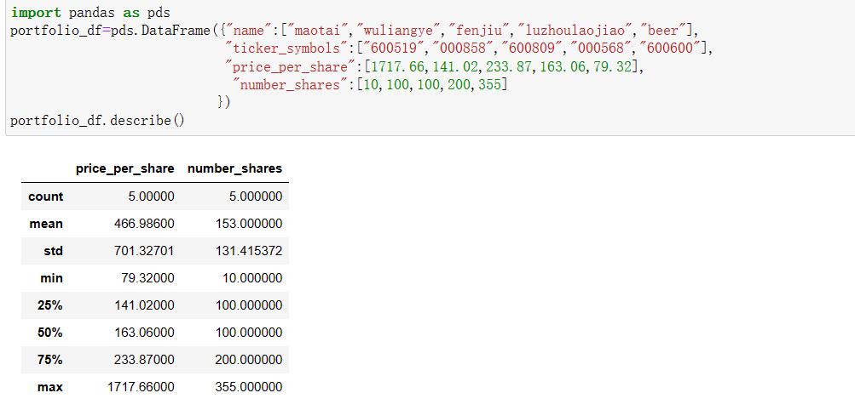

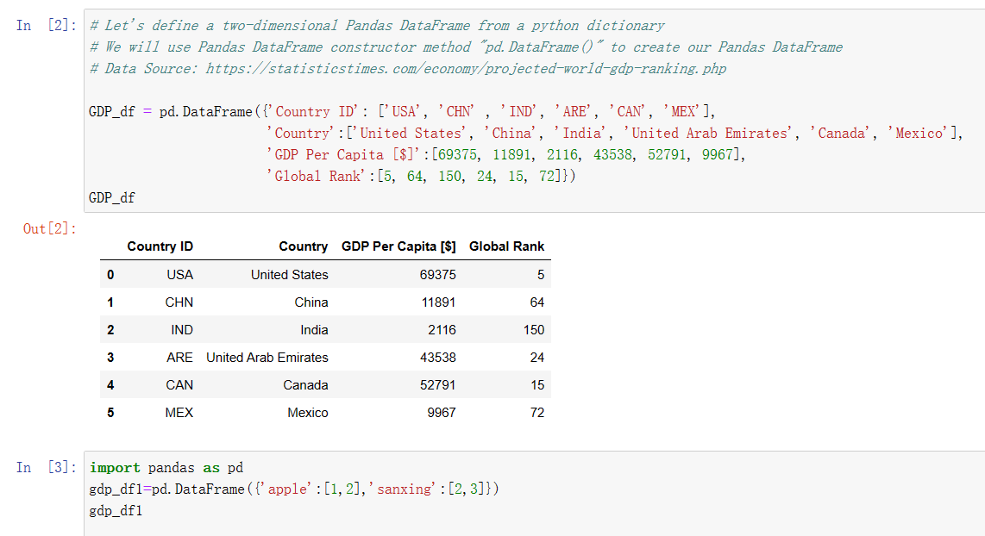

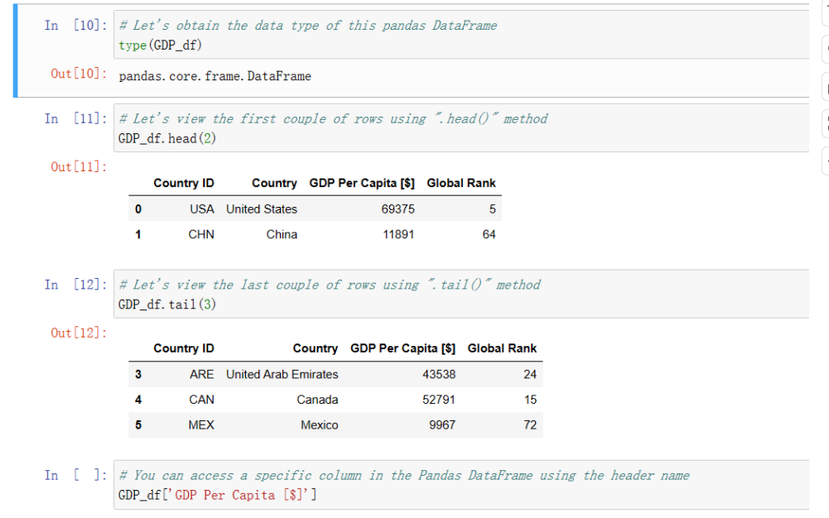

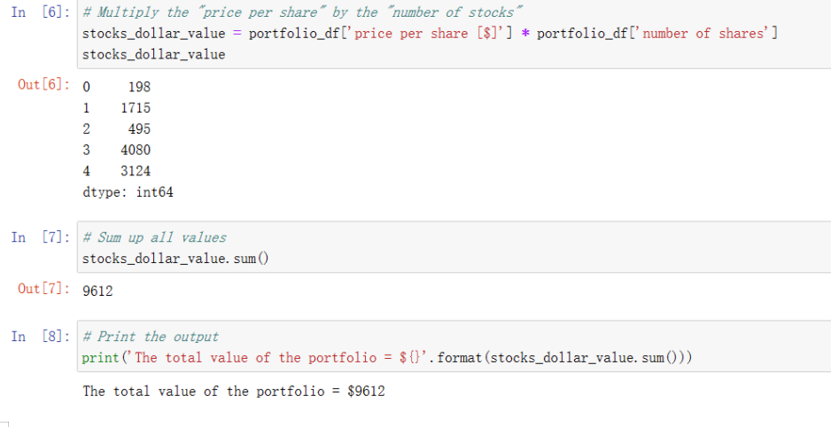

### Lesson 4.2 - Handling Missing Data with pandas

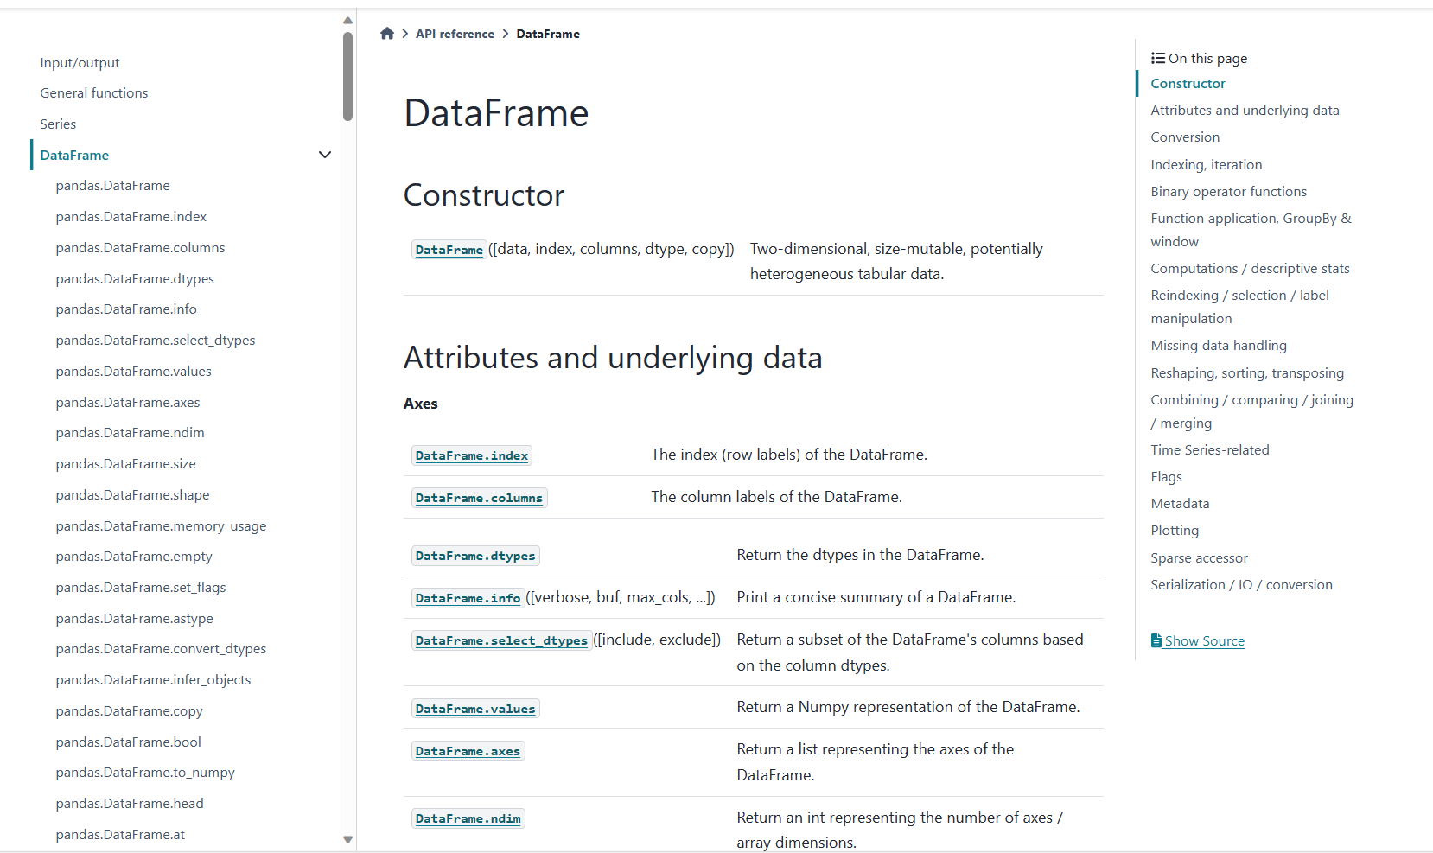

Import the “investors_data.csv” dataset using pandas.

Calculate the median value for the “Years with Investment Firm” column.

Fill in missing values in the “Years with Investment Firm” column with the median values.

Perform a sanity check.

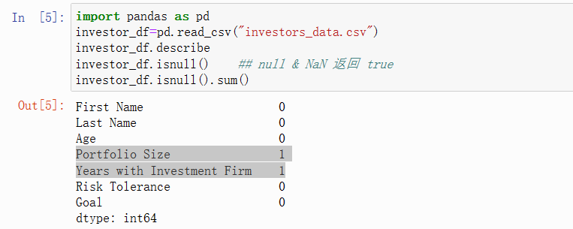

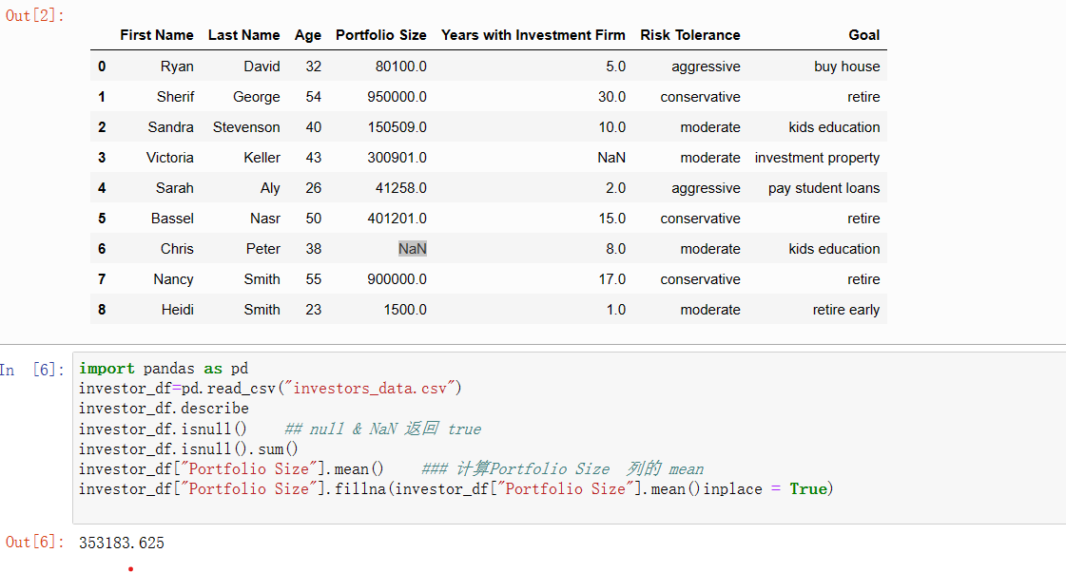

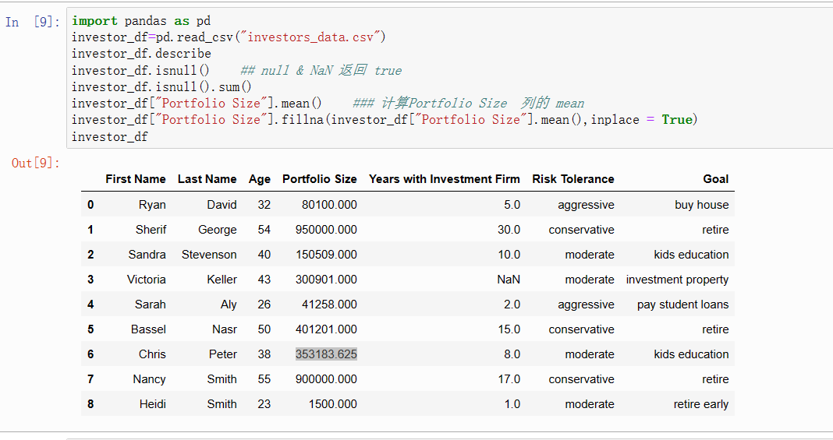

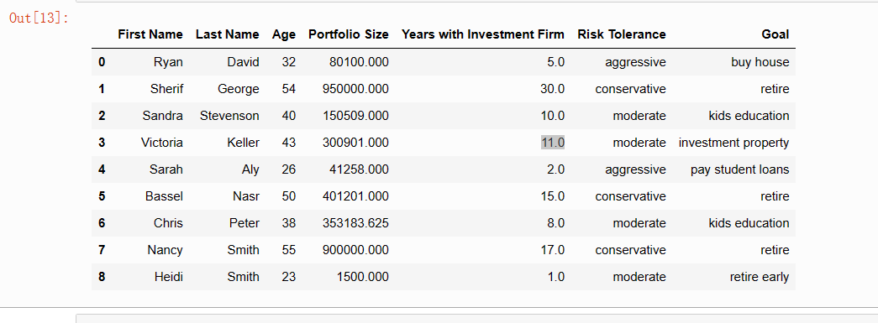

### Lesson 4.3 - DataFrame Filtering and Sorting

Data sorting is the process of organizing data into some meaningful order to make it easier to understand and examine. You can sort data in ascending or descending order. For example, data analysts might need to sort client data based on the size of their investment portfolio in an ascending order.

pandas offers key advantages over other data manipulation tools because it can handle a large amount of data, allows for process automation, and offers highly efficient data manipulation capabilities.

Sort pandas DataFrames by the values of one or more columns

Use the “ascending” parameter to choose the sort order (ascending or descending),

Use the “inplace” parameter to enforce pandas DataFrame changes to take place in memory, and

Filter out pandas DataFrames using a specific condition.

Import the “investors_data.csv” using pandas.

Sort the pandas DataFrame using the “Age” column from **oldest to youngest** in descending order. Make sure to enforce the change to take place in memory. (External research is required.)

Leverage pandas operations to select only high-net-worth individuals with a minimum portfolio size of $500,000.

Determine the combined portfolio size for all customers with a net worth of $500,000+.

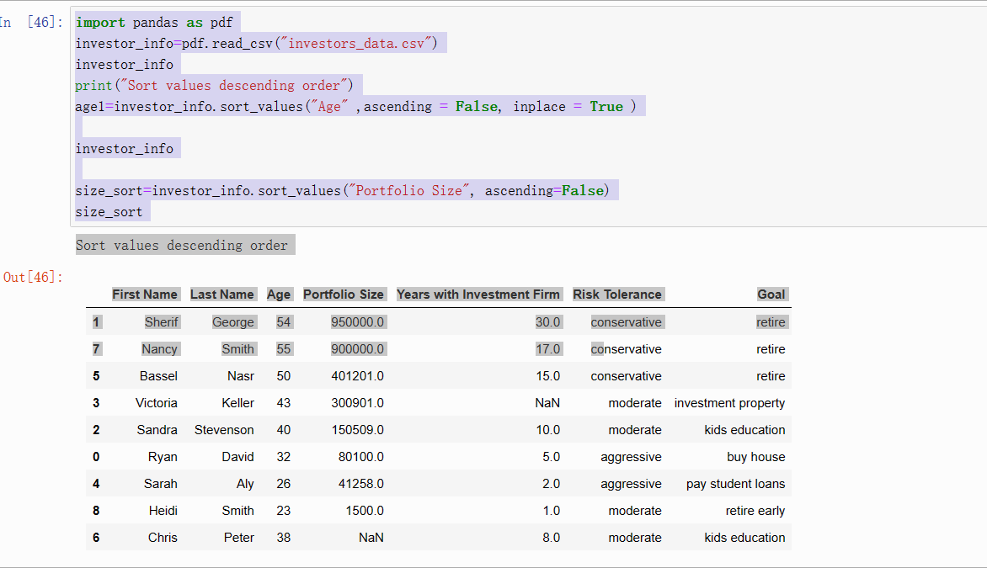

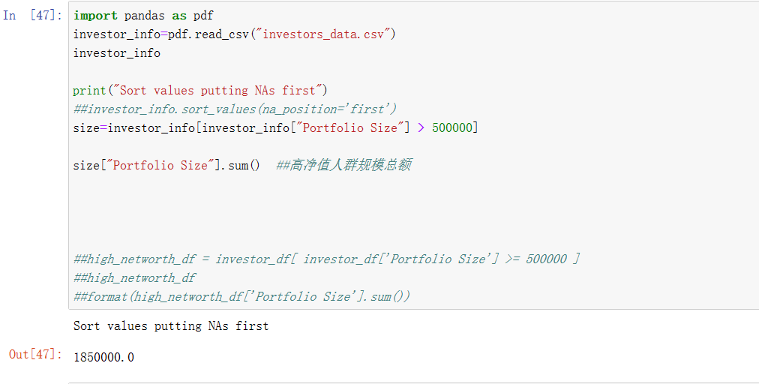

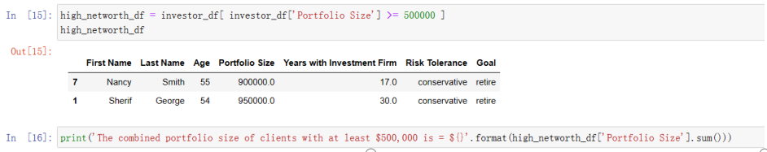

#### Lesson 4.4 - pandas DataFrames and Functions

We can apply a function to specific elements in a pandas DataFrame using the .apply() function. You can choose to apply Python built-in functions, such as sum(), min() or max(), or use any custom function that you create.

In this lesson, you will learn to:

Define a Python function,

Apply a custom function along an axis in a pandas DataFrame, and Apply Python built-in functions to pandas DataFrames.

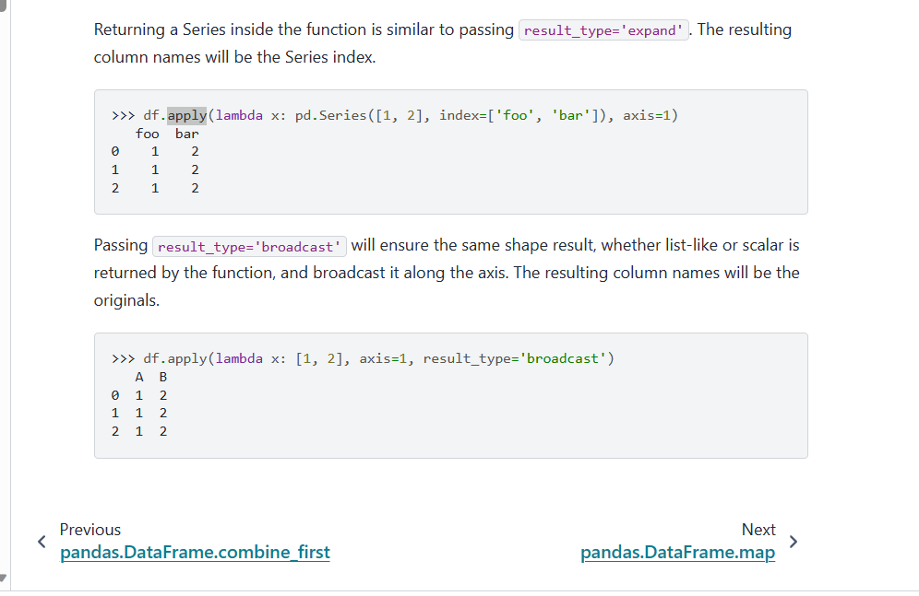

Write some Python code that performs the following tasks:

Import the “investors_data.csv” dataset and place it in “investor_df” DataFrame using pandas.

Define a function named “ranking” that receives the portfolio size and adds one of the following ranks:

Low: Client portfolio size is less than $100,000

Medium: Client portfolio size is between $100,000 and $500,000

High: Client portfolio size is more than $500,000

Apply the function to the “investor_df” DataFrame, and add the output to a new column titled “Rank.”

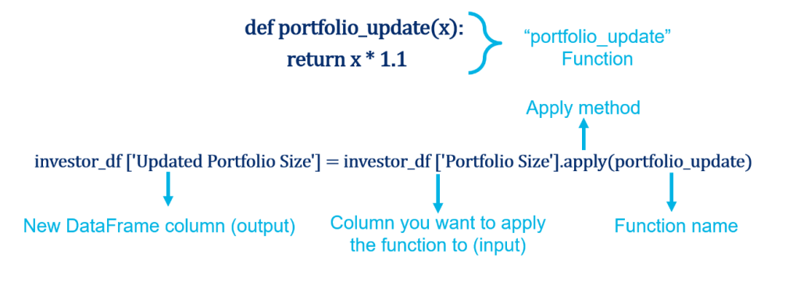

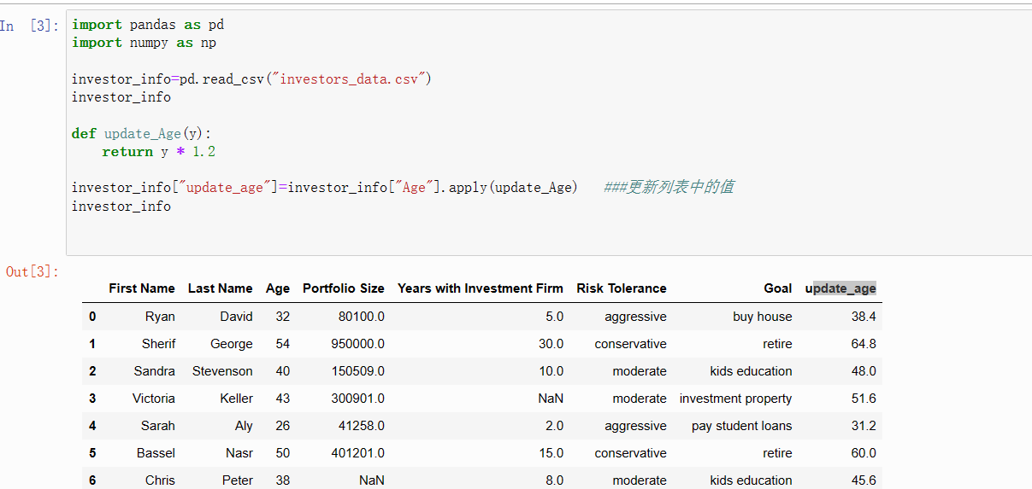

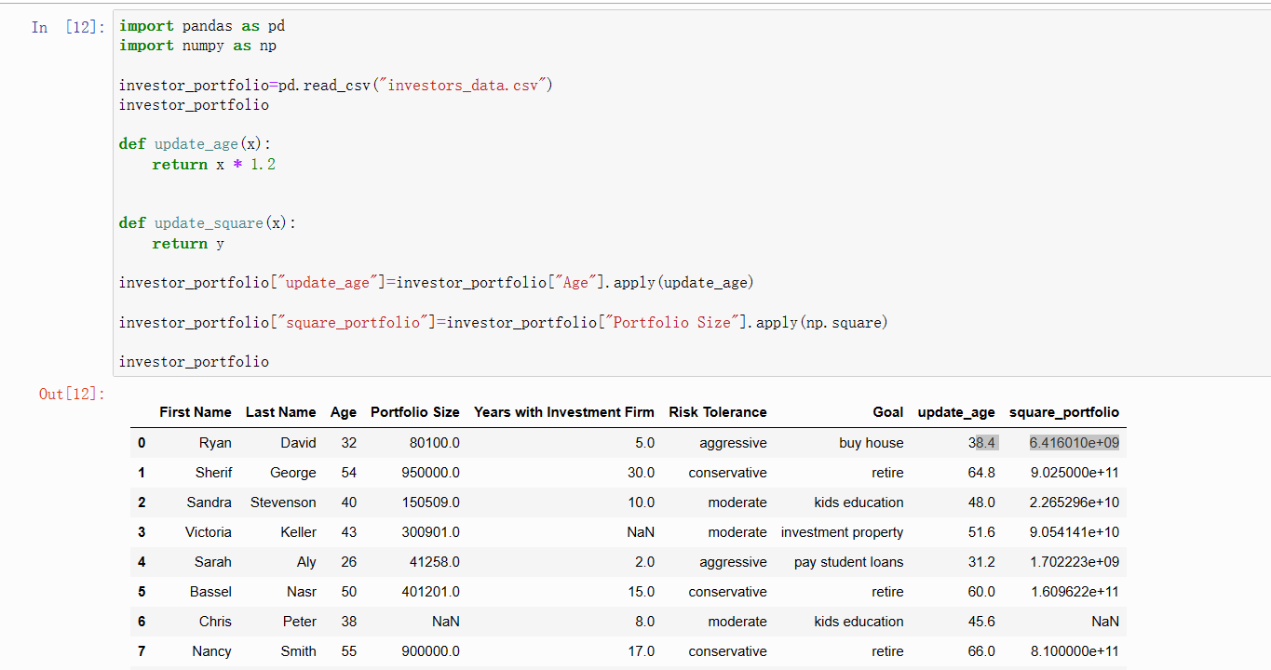

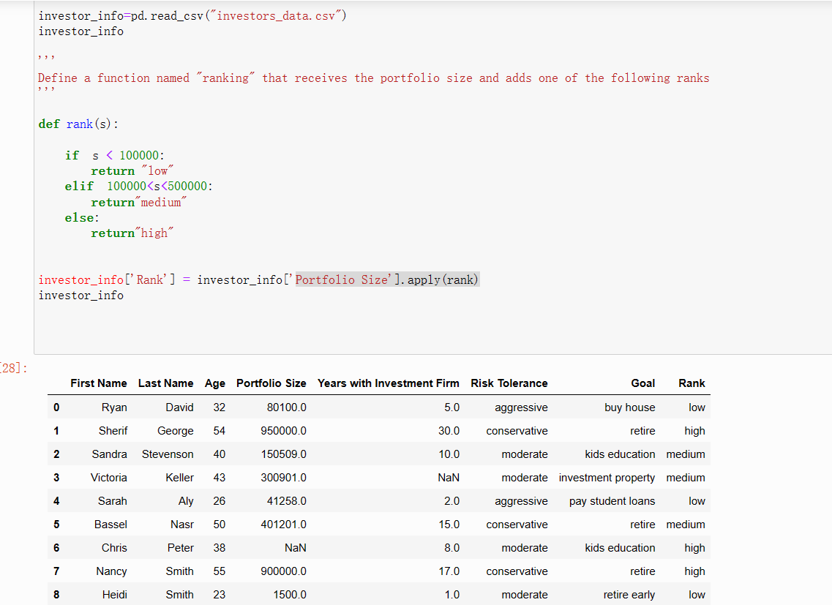

#### Lesson 4.5 - pandas DataFrames Concatenation and Merging

Assume that you became a new client of an investment firm that has its data stored in “investor_df.” Write a Python code that performs the following:

Define a new pandas DataFrame named “new_client_df” that contains your information, such as client ID (choose C1), first name, last name, age, portfolio size, years with investment firm, risk tolerance, goal, salaries, and job title.

Concatenate this new DataFrame to the original pandas DataFrame “investor_df.”

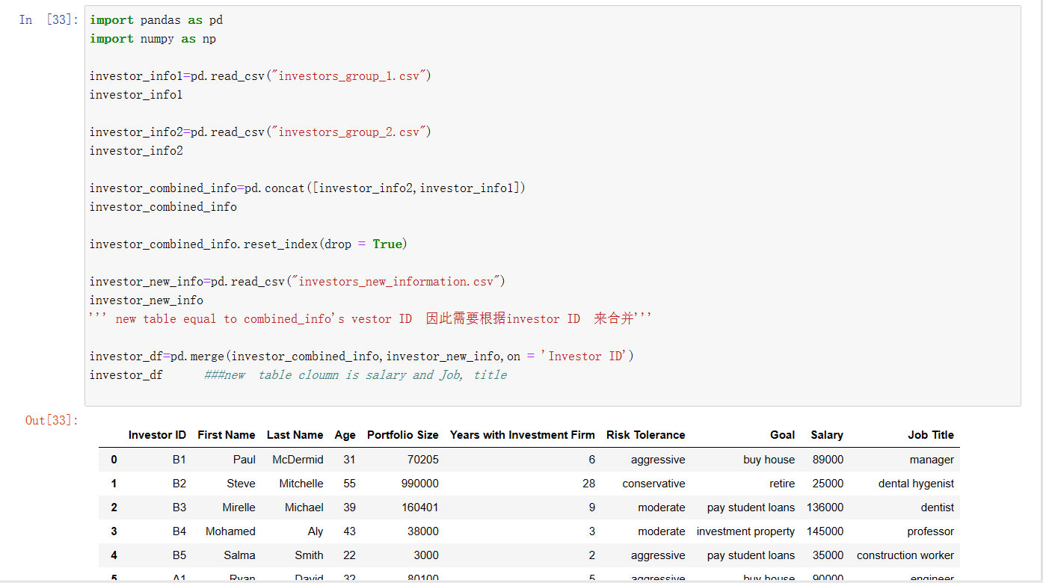

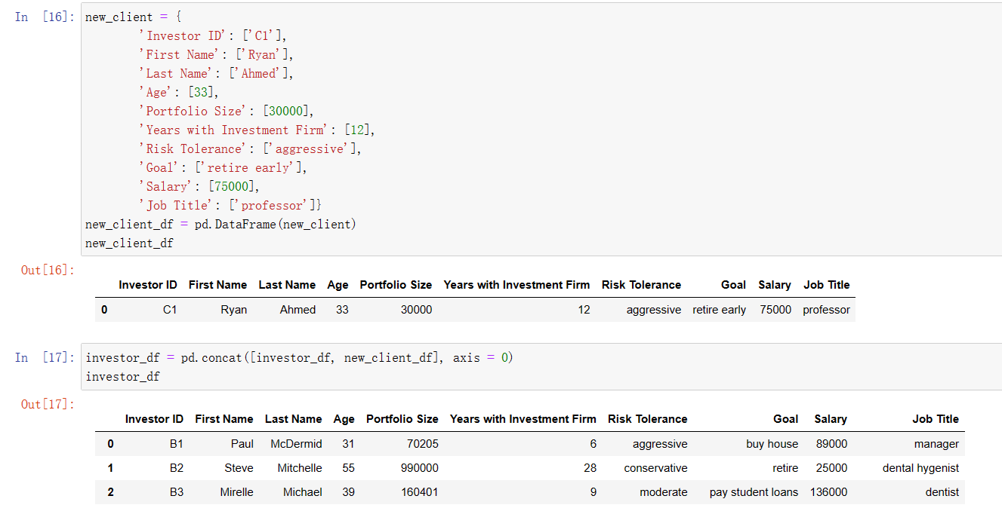

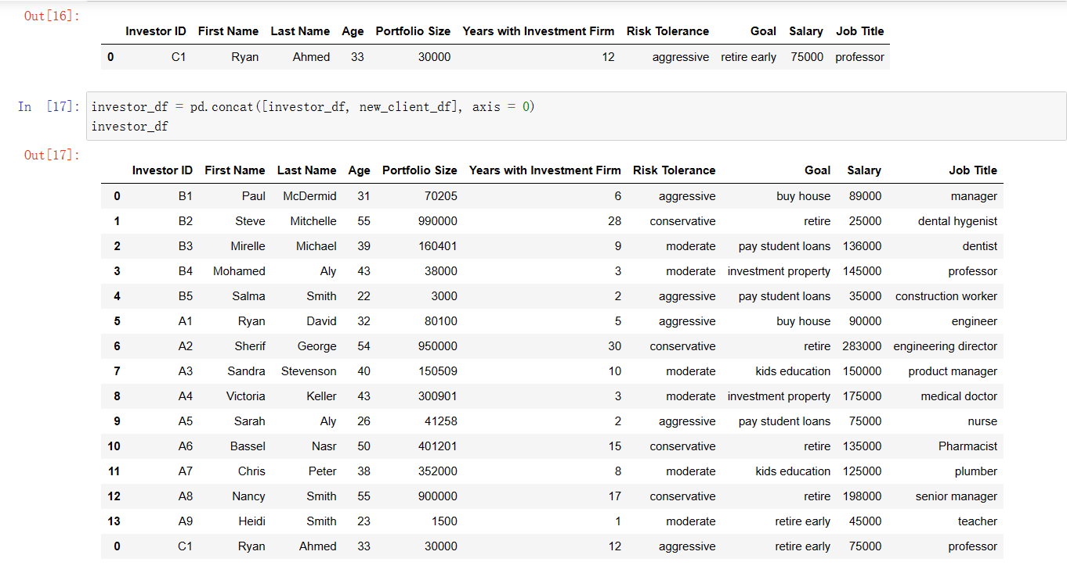

#### Lesson 4.6 - Get Financial Markets Data yfinance

Use the yfinance tool to obtain financial market data, such as stock prices, beta, earnings per share (EPS), balance sheets, and income statements;

Leverage available methods to display stocks’ paid dividends, stock splits, and analysts’ ratings and recommendations; and finally,

Obtain cryptocurrency data, such as closing price and circulating supply

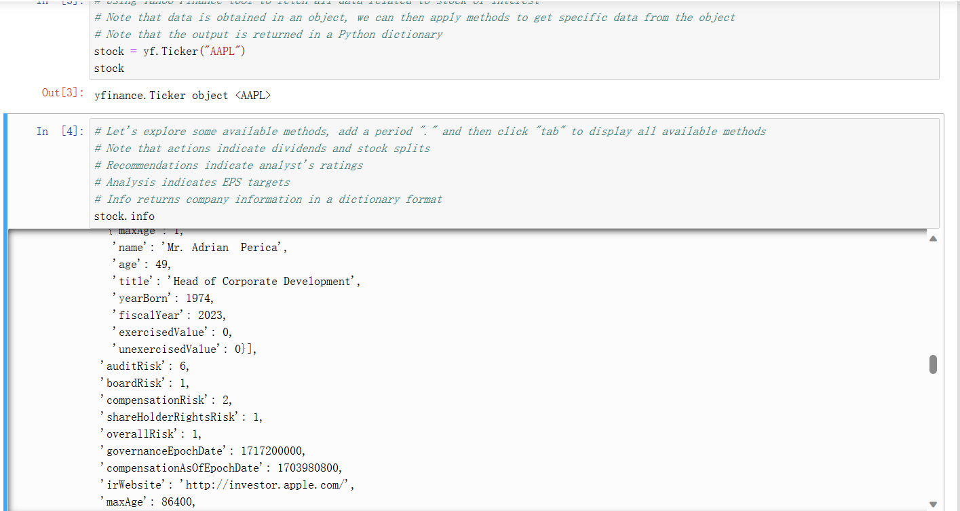

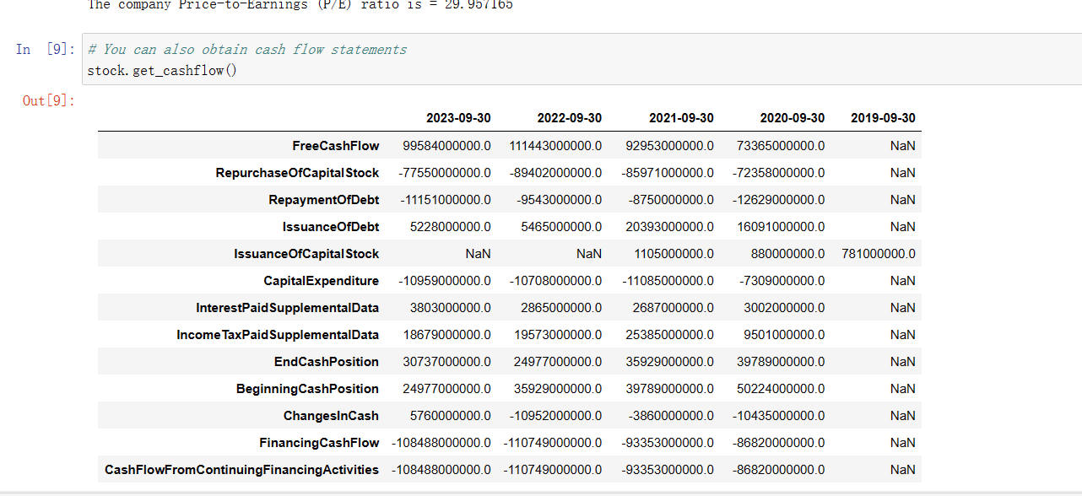

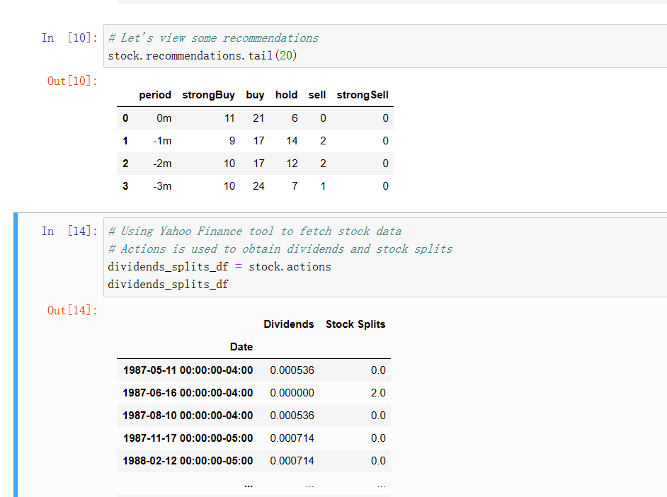

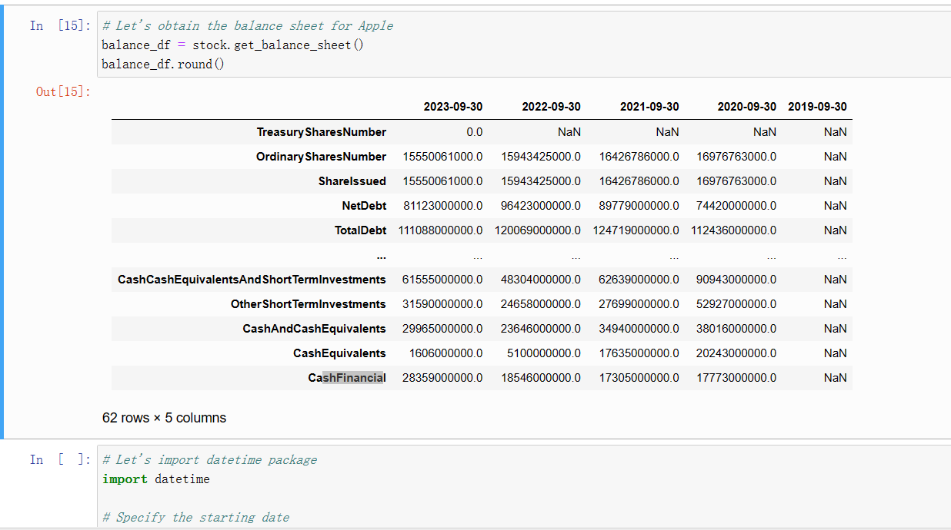

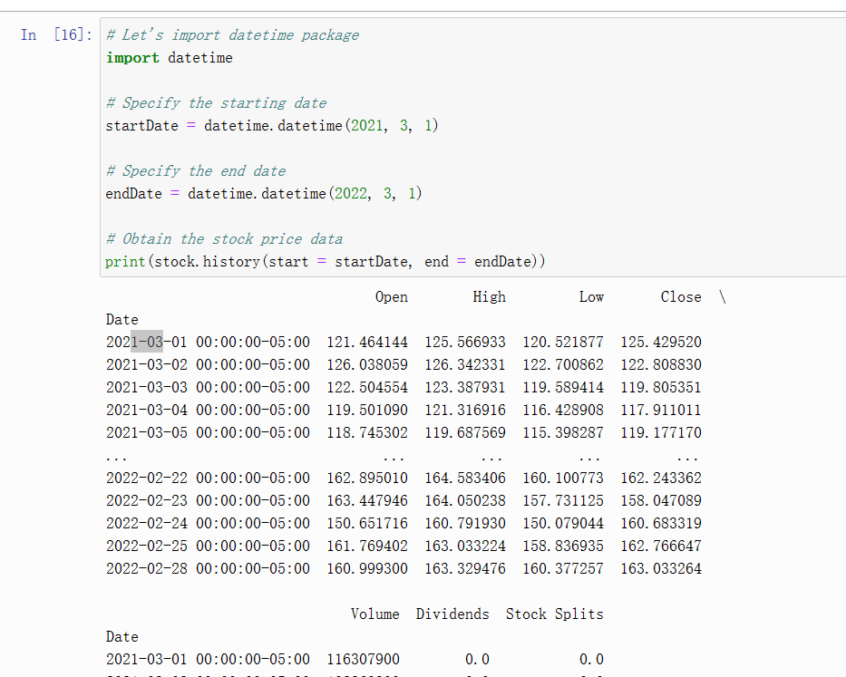

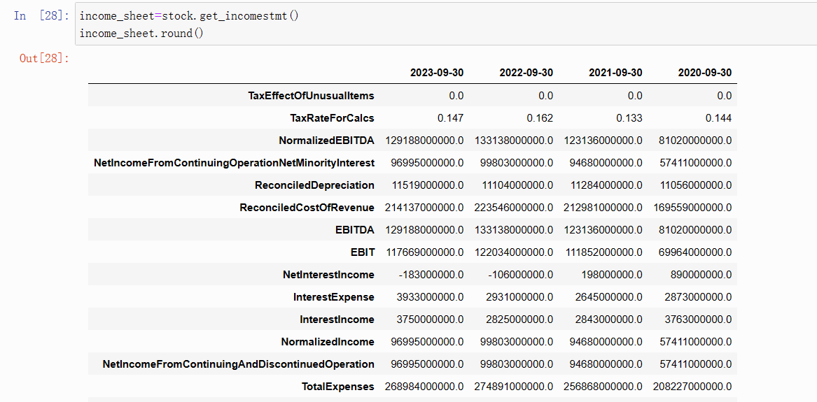

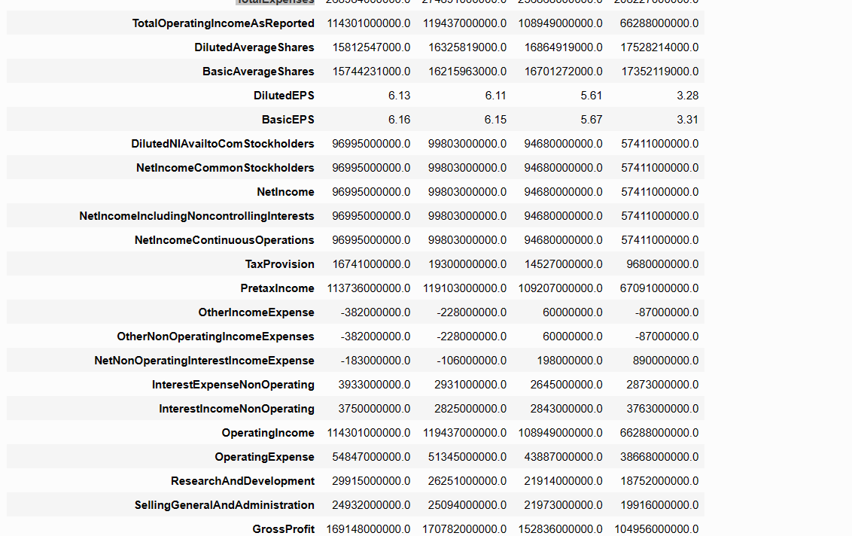

### **[Unit 5: Final Capstone Project](https://www.cfainstitute.org/programs/cfa/python-programming-fundamentals" \l "d5f4afcf2a4c47a09bd0db9a48fd40e6)**

Portfolio optimization is the process of selecting the best portfolio out of a set of available portfolios with the goal of maximizing returns and reducing risks

This case study covers many programming fundamentals that we covered in previous lessons, such as getting real-world market financial data, performing data analysis with pandas, and leveraging functions, loops, and if-else statements.

* Master Python programming fundamentals through a practical real-world project.
* Obtain real-world financial data using Pandas DataReader; data is obtained from many sources such as Yahoo Finance, NASDAQ, and many more.
* Leverage key Python libraries such as Pandas for Data Analysis, Matplotlib for data plotting/visualization, and Seaborn for statistical plots in a financial context.
* Use the Plotly Express Library to perform interactive financial data visualization.
* Calculate portfolio key statistical metrics such as returns, risk, and Sharpe ratio in Python.

Perform portfolio analysis and visualization using real-world datasets

* Run Monte Carlo simulations and perform portfolio optimization.
* help(np.linspace)

#### Lesson 5.1 - Import Key Libraries and Datasets

Using the pandas library, read JPMorgan Chase & Co. stock price data contained in the “JPM.csv” file and place it in a pandas DataFrame entitled “JPM_df.”

Count the number of null or missing values in the “JPM_df” pandas DataFrame.

Identify the memory usage of the “JPM_df” pandas DataFrame.

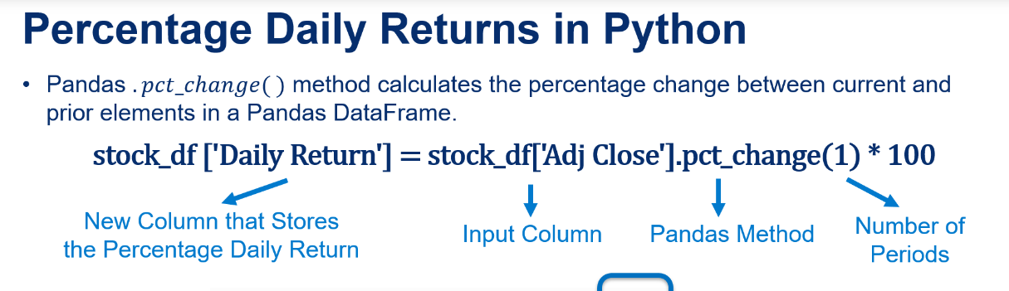

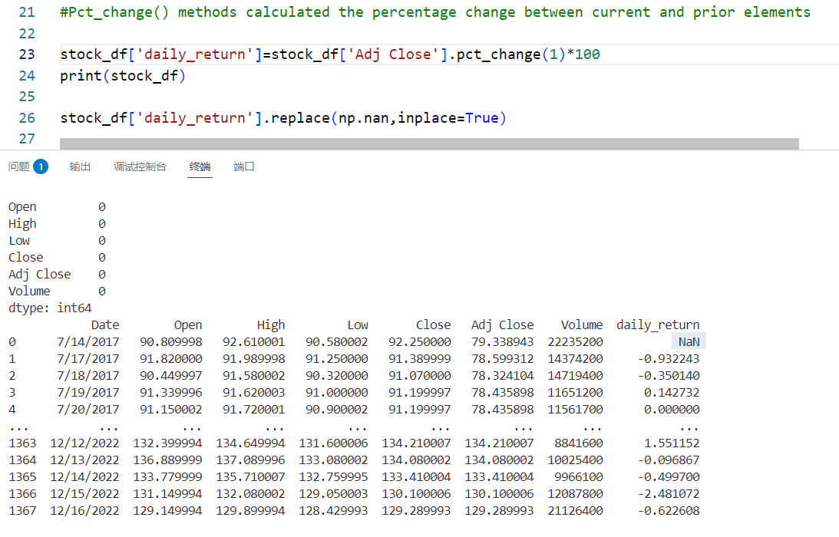

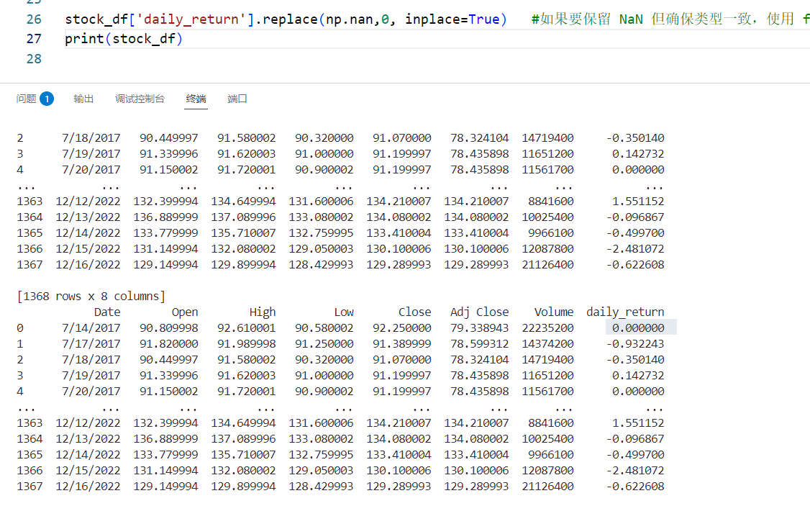

#### 5.2Matplotlib

In this capstone project,we will perform portfolio analysis, viasualization and optimization

A portfolio is a collection of financial assets such as stocks, bonds ,cash and real estate.

The purpose of a portfolio is to diversify the investments and manage risks.

Portfolio optimization is the process of selecting the optimal portfolio out of a set of available

Portfolios with the objective of maximizing returns and reducing risks.

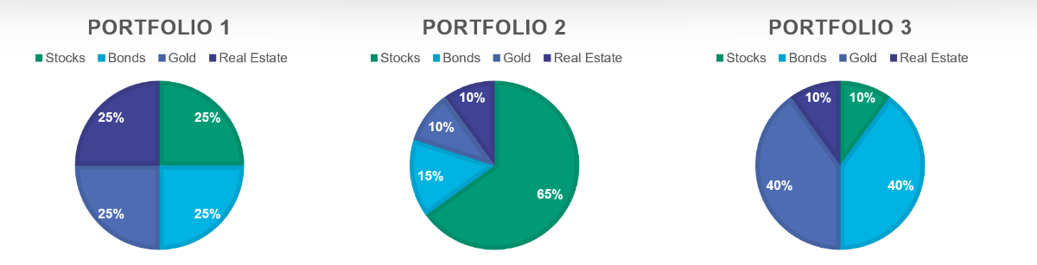

* ****Using Pandas library, read JPMorgan Chase & Co. stock prices data contained in "JPM.csv" file and place it in a Pandas DataFrame titled "JPM_df"****
* ****Count the number of Null or missing values in "JPM_df" Pandas DataFrame****
* ****What is the memory usage of "JPM_df" Pandas DataFrame?****

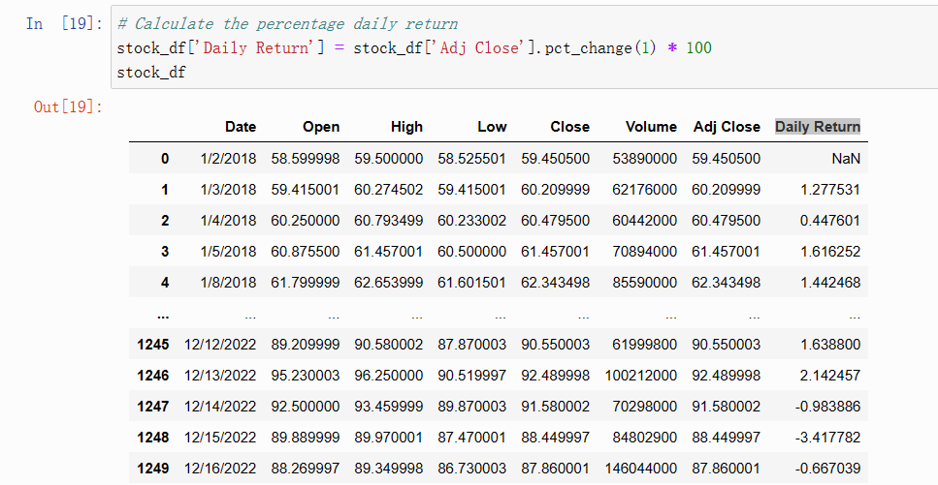

# Let's replace the first row with zeros instead of NaN

stock_df['Daily Return'].replace(np.nan, 0, inplace = True)

stock_df

# Use the describe() method to obtain a statistical summary about the data

# Over the specified time period, the average adjusted close price for Amazon stock was $120.07

# The maximum adjusted close price was $186.57

# The maximum volume of shares traded on one day were 311,346,000

stock_df.describe().round(2)

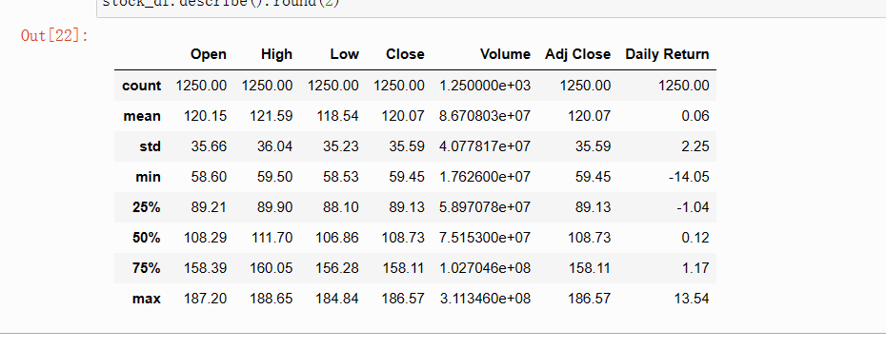

Using the adjusted closing price, calculate the percentage daily return for JPMorgan chase & Co.stock starting from July 14 th , 2017 until december 16th ,2022

Calculate the maximum percentage daily return for JPMorgan Chase & C0.stock over the same time period.

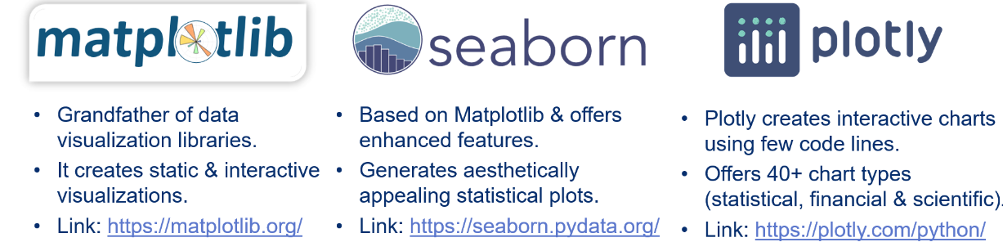

import matplotlib.pyplot as plt

!pip install seaborn

import seaborn as sns

import plotly.express as px

# Plot a Line Plot Using Plotly Express 使用Plotly Express绘制直线图

fig = px.line(title = 'Amazon.com, Inc. (AMZN) Adjusted Closing Price [$]')

fig.add_scatter(x = stock_df['Date'], y = stock_df['Adj Close'], name = 'Adj Close')

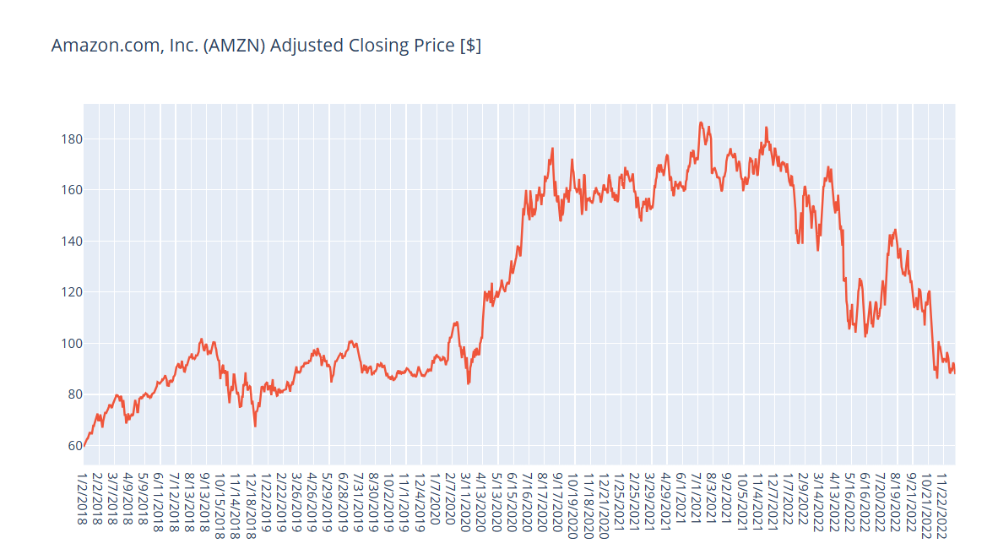

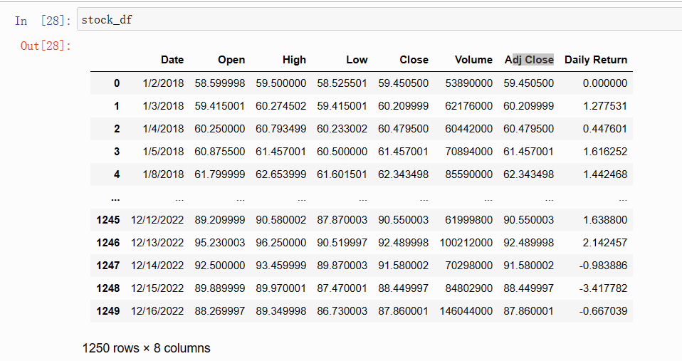

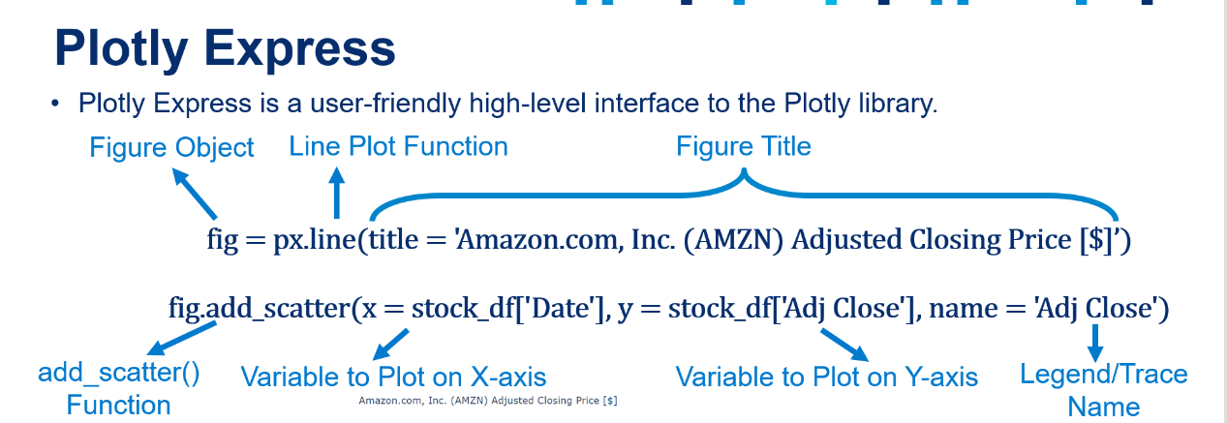

# Define a function that performs interactive data visualization using Plotly Express

def plot_financial_data(df, title):

fig = px.line(title = title)

# For loop that plots all stock prices in the pandas dataframe df

For循环，它绘制熊猫数据帧df中的所有股票价格

# Note that index starts with 1 because we want to skip the date column

for i in df.columns[1:]:

fig.add_scatter(x = df['Date'], y = df[i], name = i)

fig.update_traces(line_width = 5)

fig.update_layout({'plot_bgcolor': "white"})

fig.show()

plot_financial_data(stock_df.drop(['Volume', 'Daily Return'], axis = 1), 'Amazon.com, Inc. (AMZN) Stock Price [$]')

# Plot High, Low, Open, Close and Adj Close

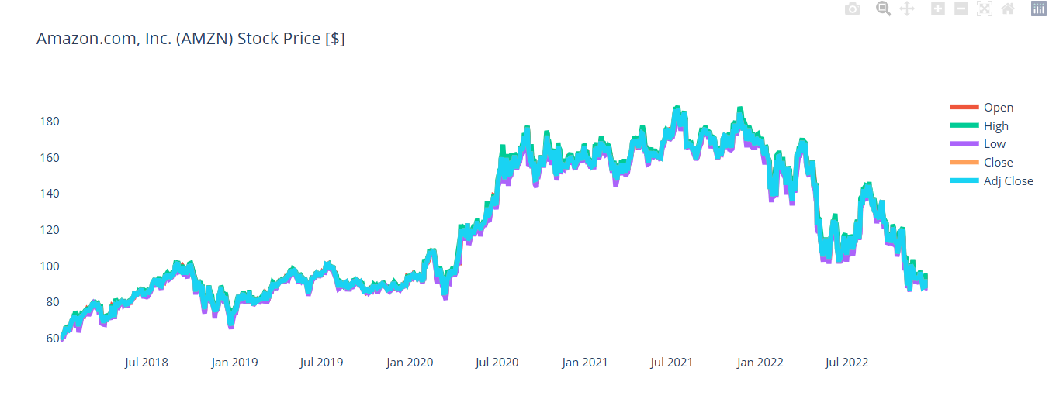

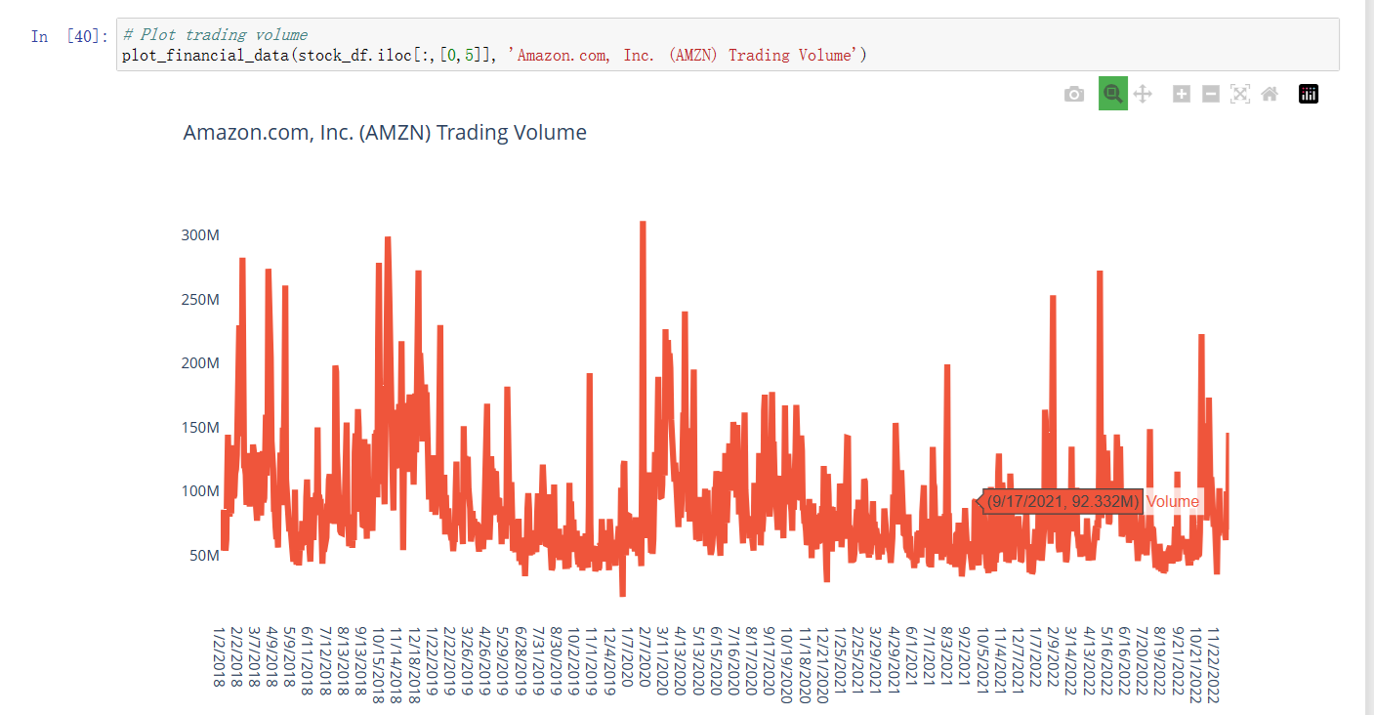

# Plot % Daily Returns

plot_financial_data(stock_df.iloc[:,[0,7]], 'Amazon.com, Inc. (AMZN) Percentage Daily Return [%]')

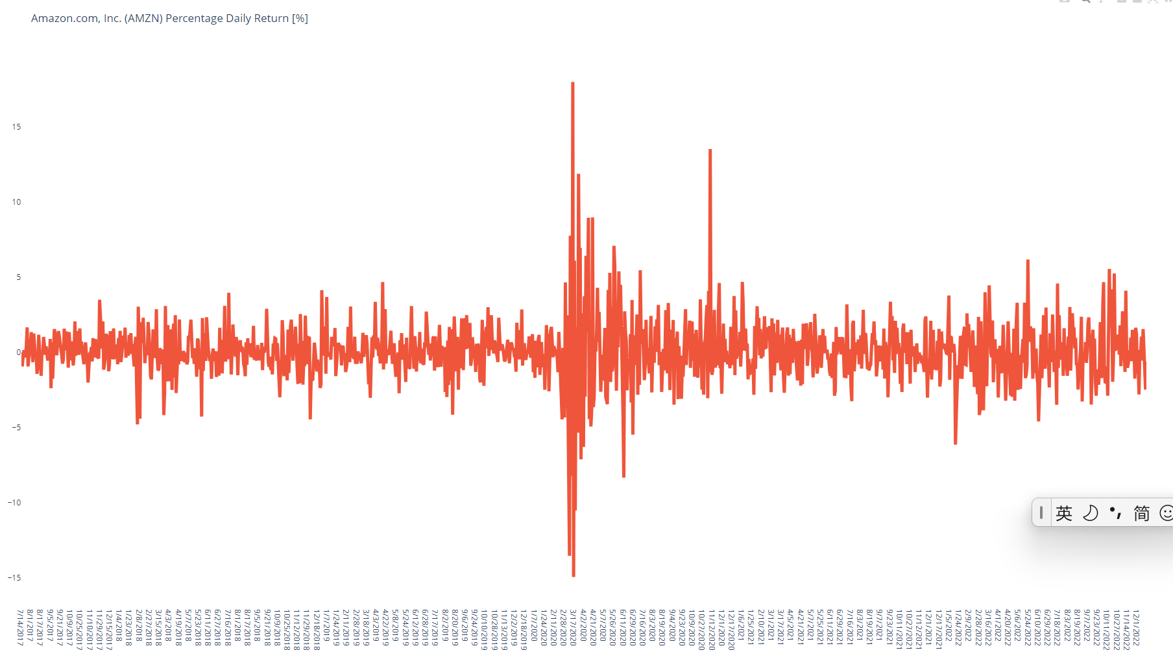

根据 Daily_return 分类回报范围，预测趋势

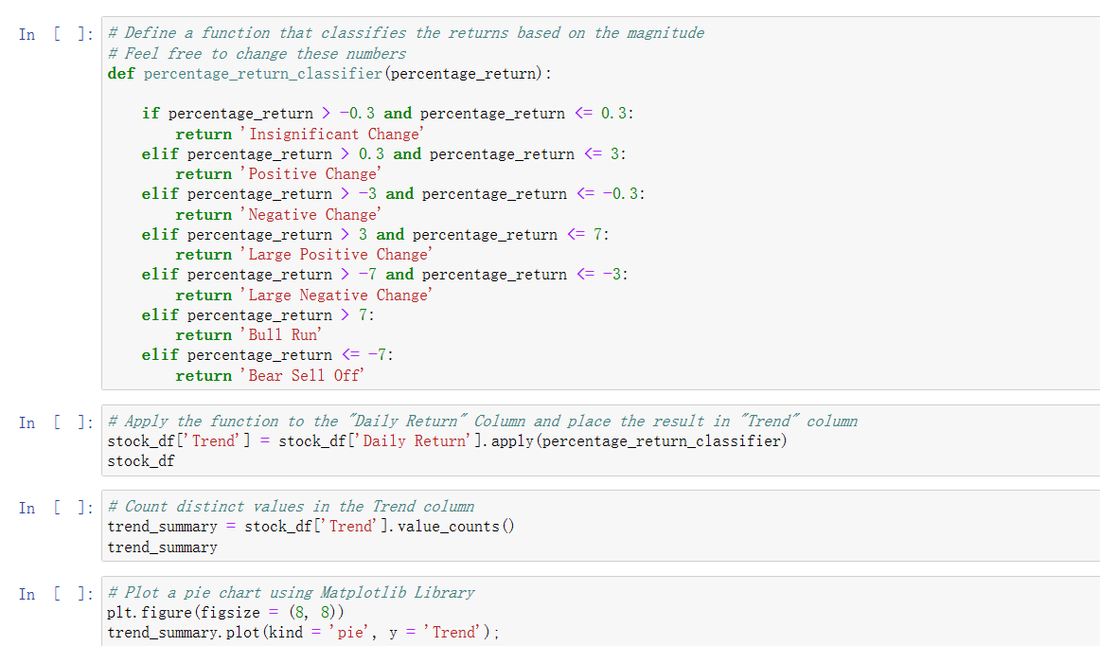

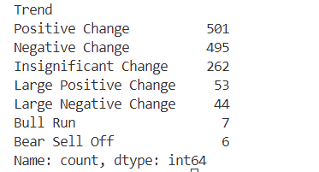

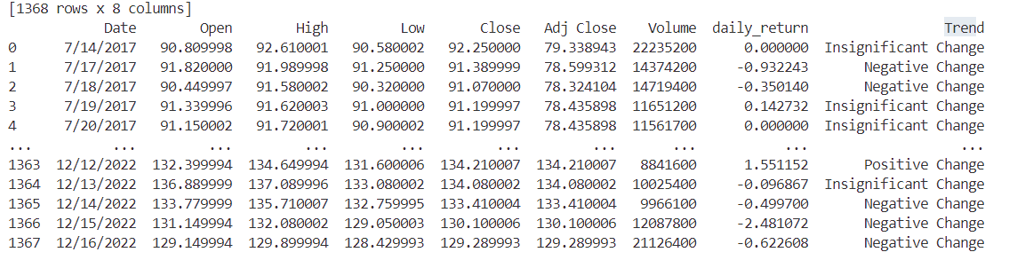

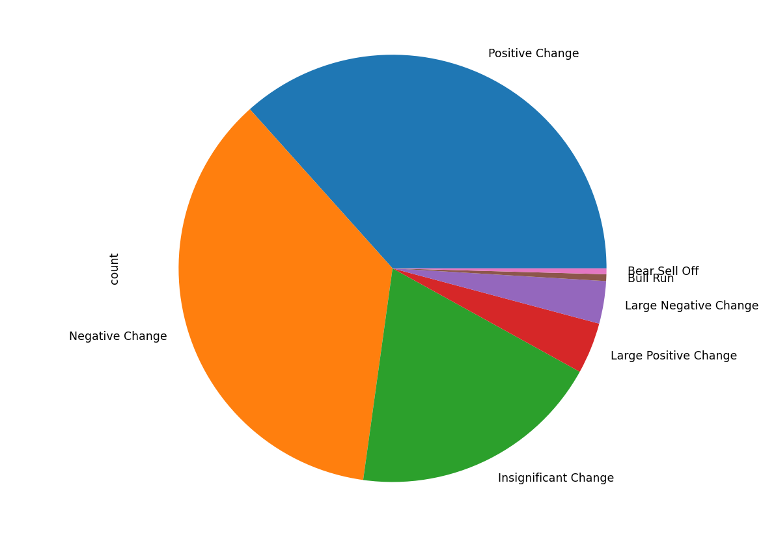

##### PERFORM DATA VISUALIZATION FOR A SINGLE STOCK: PART 3

Candlestick graph is a powerful trading tool that displays four price points(high、low\open and close) for a given stock in a specified time period.

Candlestick graph 蜡烛图is used for predicting market trends and understanding market sentiment.

The “real body” displays the range between open and close price while “shadows” represent the highest and lowest price traded during the specified time period.

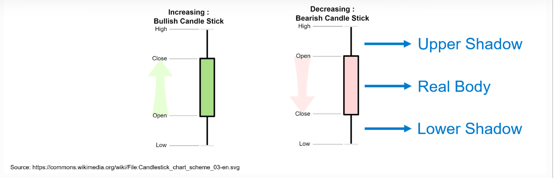

# Let's plot a candlestick graph using Cufflinks library

# Cufflinks is a powerful Python library that connects Pandas and Plotly for generating plots using few lines of code

# Cufflinks allows for interactive data visualization

# Let's read multiple stocks data contained in "stock_prices.csv" attached in the course package

# The Appendix includes details on how to obtain this data using yfinance and Pandas Datareader

# Note that yfinance and Pandas Datareader might experience outage in some geographical regions

# We will focus our analysis on U.S. stocks, similar analysis could be performed on

Asian, European or African stocks

# AMZN: Amazon Inc. - Multinational tech company focusing on e-commerce, cloud computing, and artificial intelligence

# JPM: JPMorgan Chase and Co. - Multinational investment bank and financial services holding company

# META: Meta Platforms, formerly named Facebook Inc. - META owns Facebook, Instagram, and WhatsApp

# PG: Procter and Gamble (P&G) - Multinational consumer goods corporation

# GOOG: Google (Alphabet Inc.) - Multinational company that focuses on search engine tech, e-commerce, Cloud and AI

# CAT: Caterpillar - World's largest construction-equipment manufacturer

# PFE: Pfizer Inc. - Multinational pharmaceutical and biotechnology corporation

# EXC: Exelon - An American Fortune 100 energy company

# DE: Deere & Company (John Deere) - Manufactures agricultural machinery and heavy equipment

# JNJ: Johnson & Johnson - A multinational corporation that develops medical devices and pharmaceuticals

# Insert the date column at the start of the Pandas DataFrame (@ index = 0)

daily_returns_df.insert(0, "Date", close_price_df['Date'])

daily_returns_df

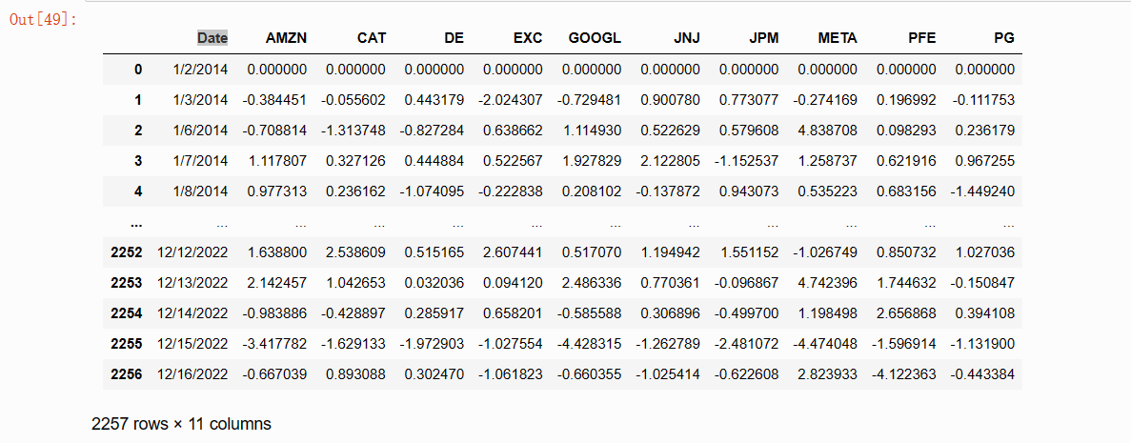

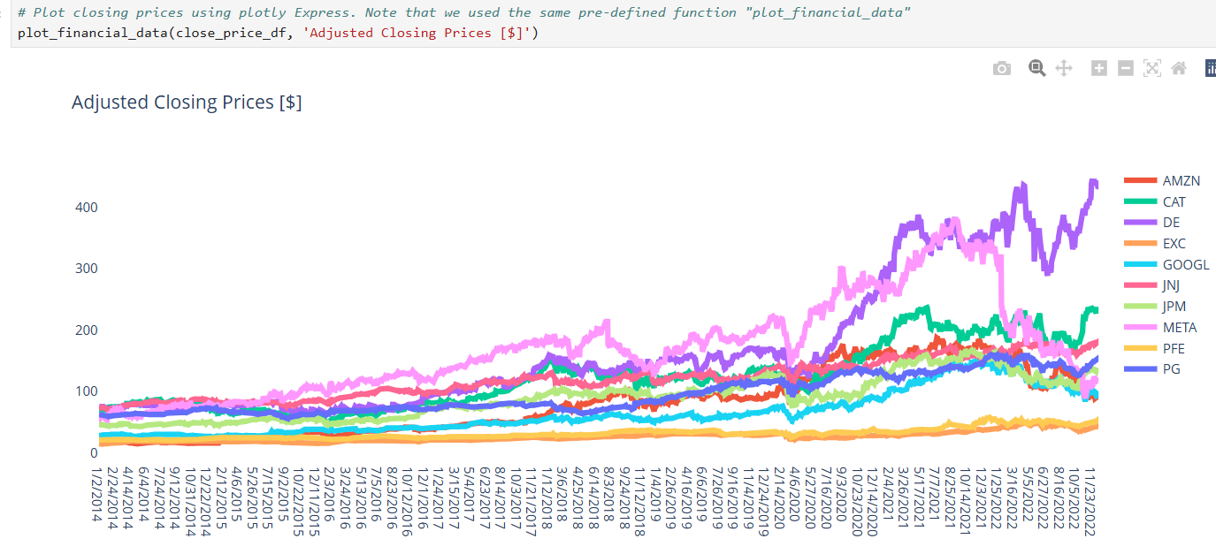

plot_financial_data(daily_returns_df, 'Percentage Daily Returns [%]')

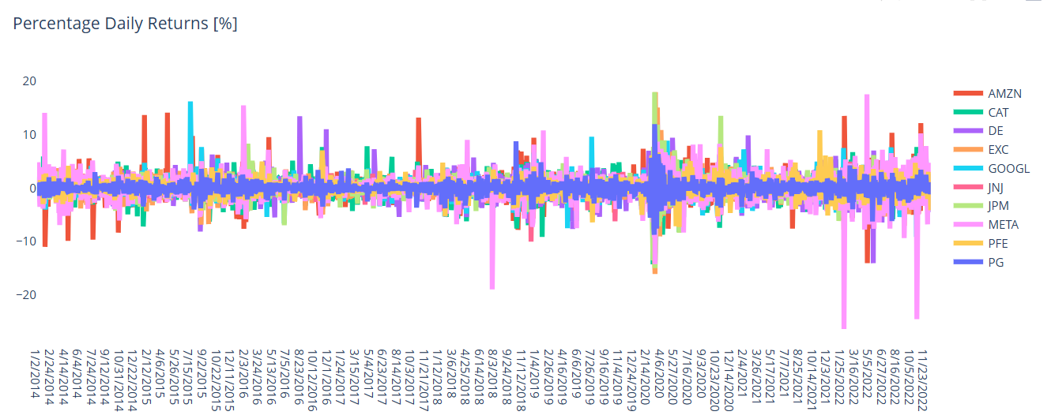

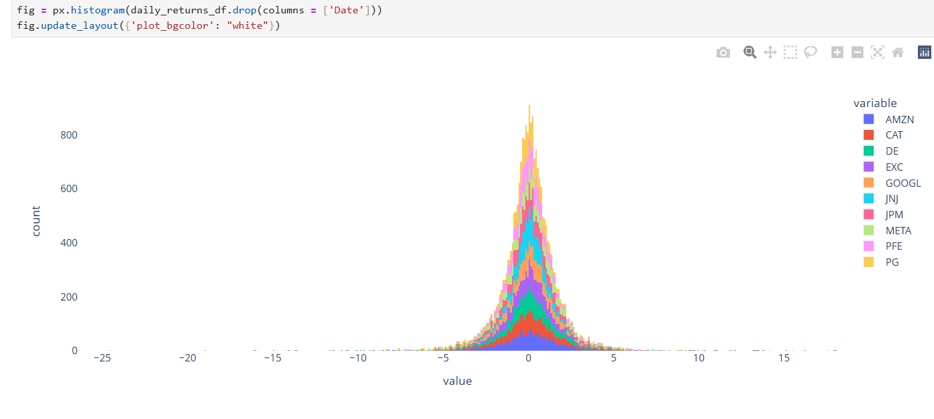

##### **Heartmap**

Strong positive corrleation

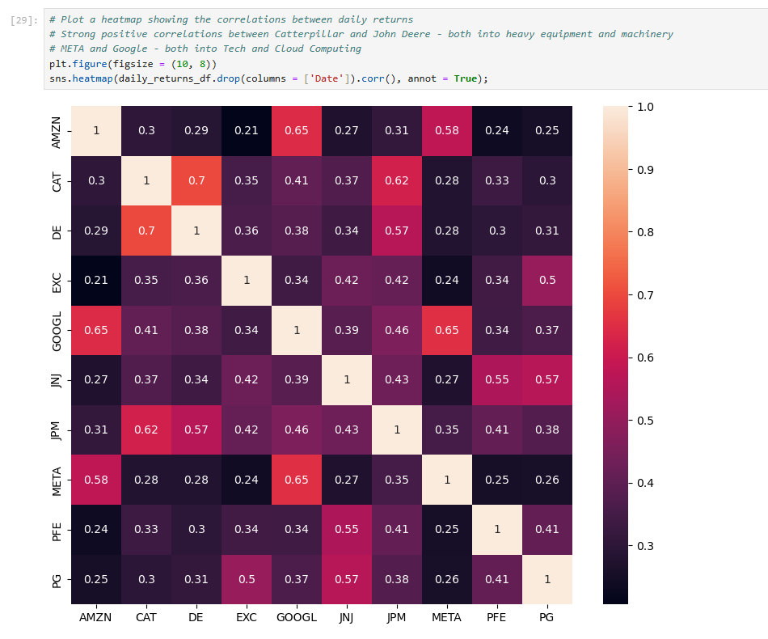

sns.pairplot(daily_returns_df);

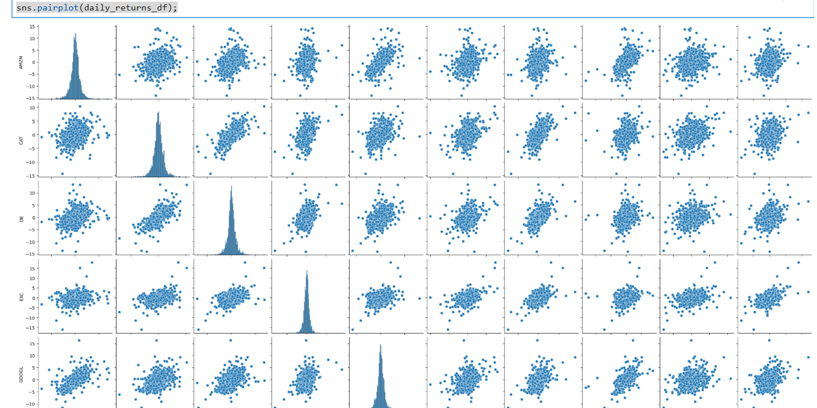

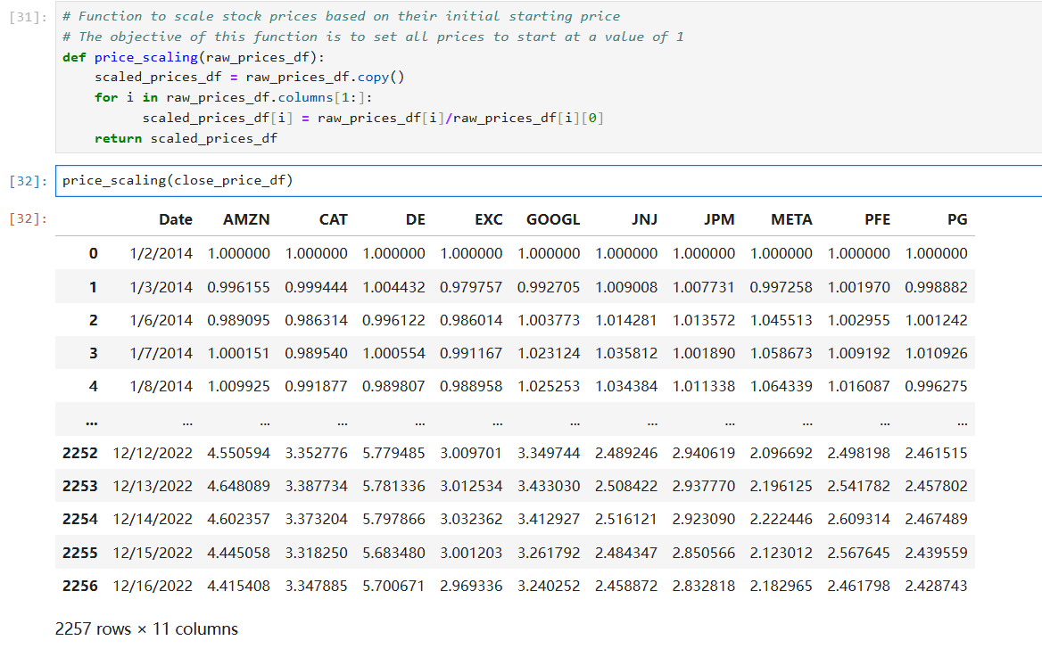

##### Sharpe Raio

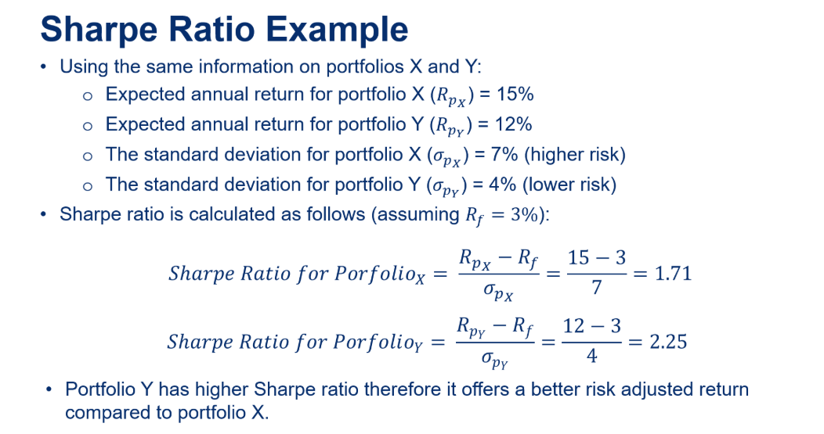

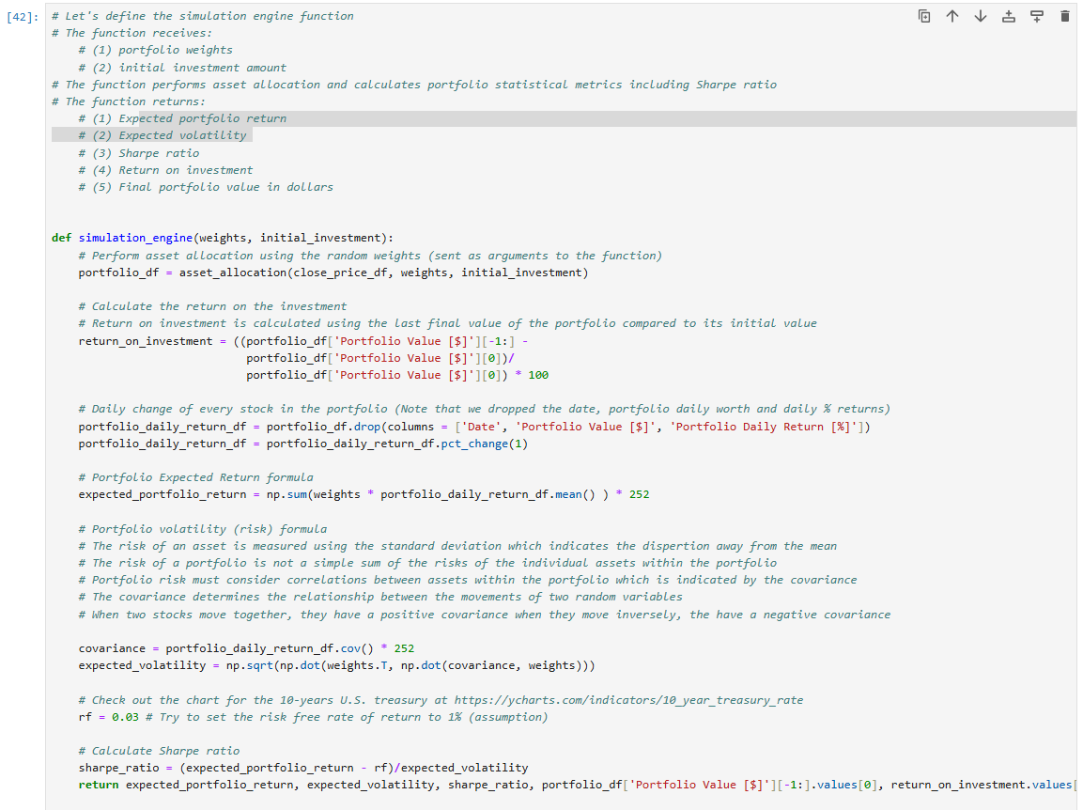

# Calculate Sharpe ratio

sharpe_ratio = (expected_portfolio_return - rf)/expected_volatility

return expected_portfolio_return, expected_volatility, sharpe_ratio,

portfolio_df['Portfolio Value [$]'][-1:].values[0], return_on_investment.values[0]

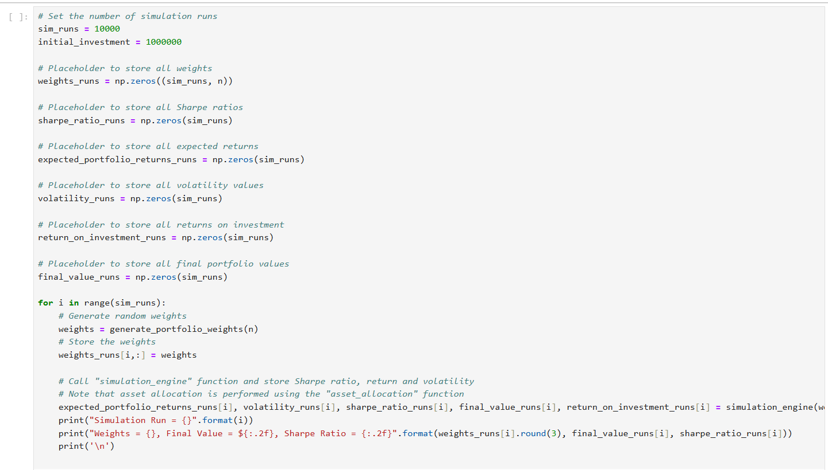

##### 马科维茨有效前沿

Efficient frontier

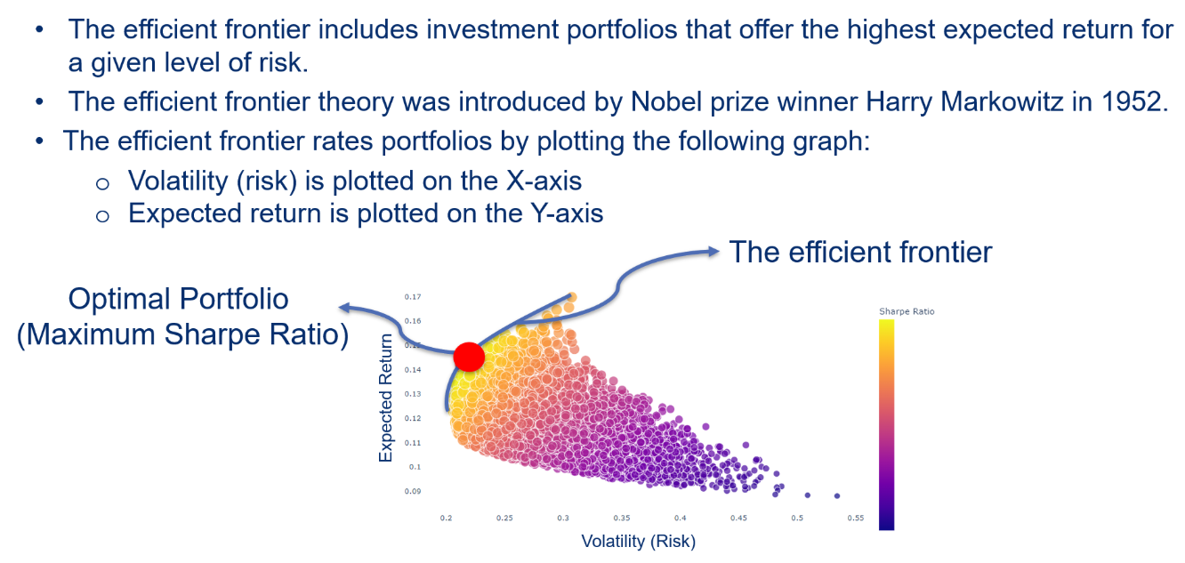

# Return Sharpe ratio, volatility corresponding to the best weights allocation (maximum Sharpe ratio)

optimal_portfolio_return,optimal_volatility,optimal_sharpe_ratio,highest_final_value, optimal_return_on_investment =simulation_engine(weights_runs[sharpe_ratio_runs.argmax(), :], initial_investment)

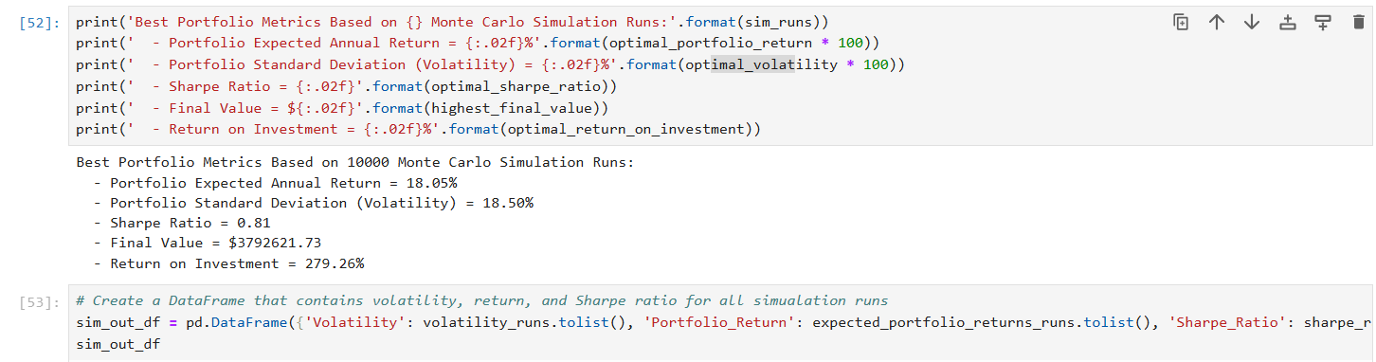

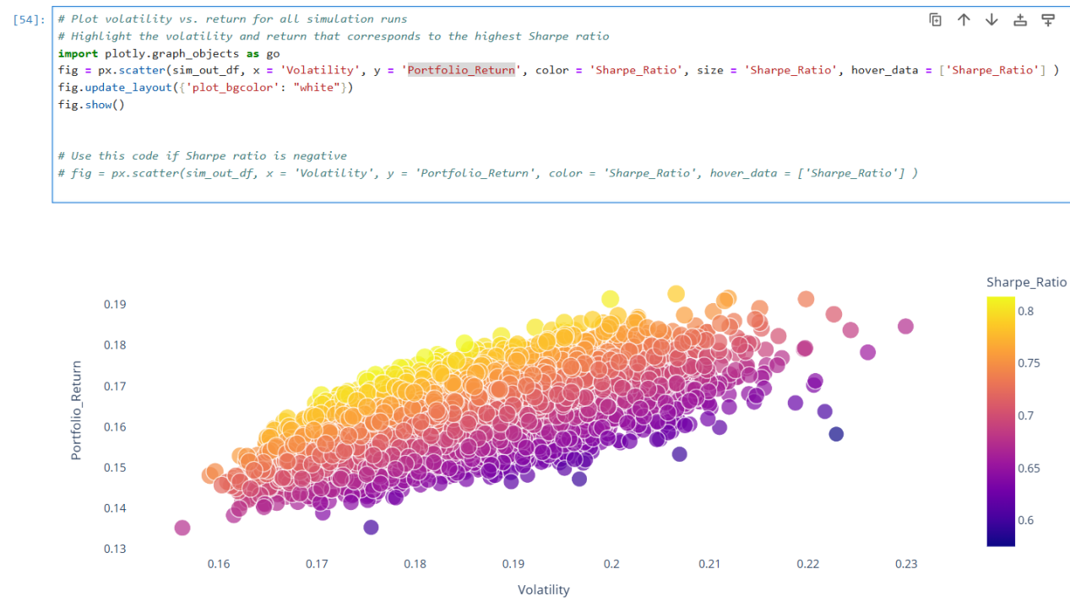

##### Monte Carlo Simulation

For 50 and 10000

**PRACTICE OPPORTUNITY SOLUTION:**

- **Assume we now have 10 stocks under consideration, test the function using the new number of stocks.**

- **Perform a sanity check and ensure that the sum of all weights is equal to 1.**

Weights

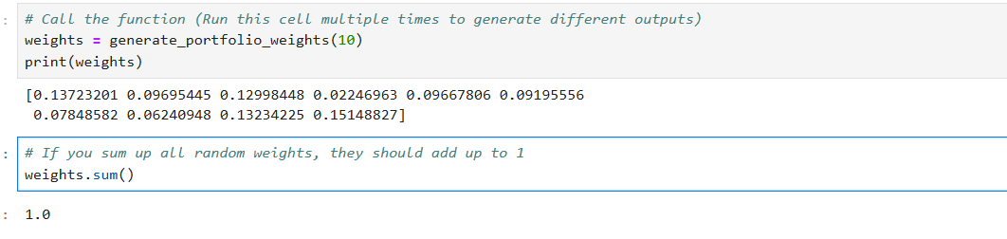

Complete following tasks:

****tasks:****

* ****Define a new "weights" list that contains equal allocation among all assets.****
* ****Call "simulation_engine" function and send it the new weights. Record the Sharpe ratio and portfolio final value.****
* ****Assume that the risk-free rate is now set to 1%. How does that change impact Sharpe ratio? confirm your answer by changing the risk free-rate, running the code, and recording the new Sharpe ratio.****

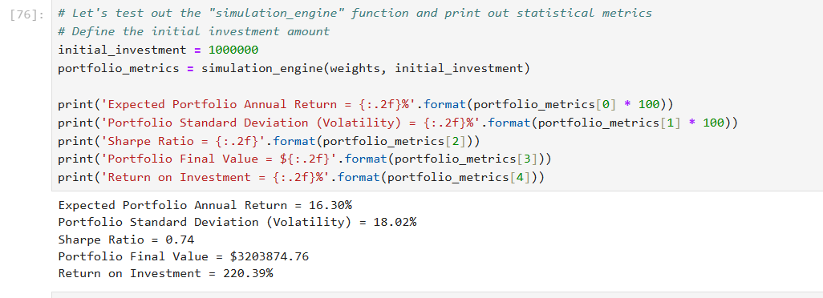

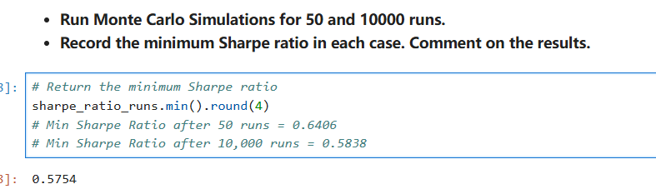

****PRACTICE OPPORTUNITY SOLUTION:****

* ****Using Plotly Express, perform the following tasks:****
  + ****plot the portfolio volatility (y-axis) vs. simulation run number (x-axis)****
  + ****Plot the portfolio return (y-axis) vs. simulation run number (x-axis)****
  + ****Plot the Sharpe ratio (y-axis) vs. simulation run number (x-axis)****
* ****Perform a sanity check by identifying the optimal simulation run that results in the highest Sharpe ratio****

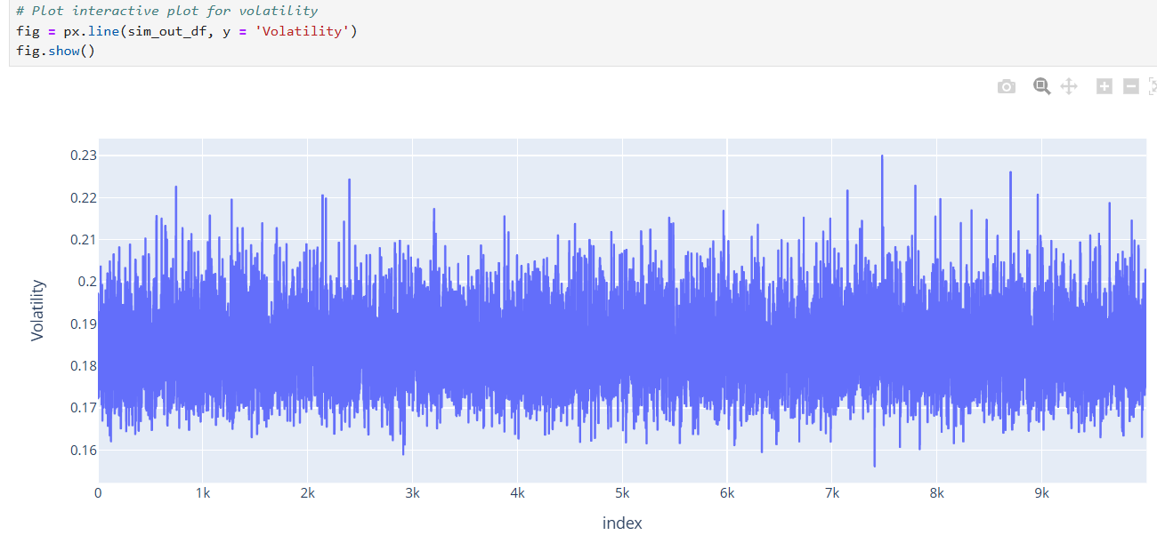

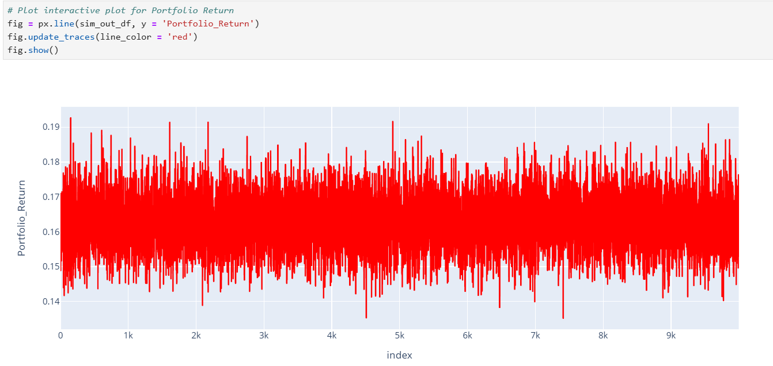

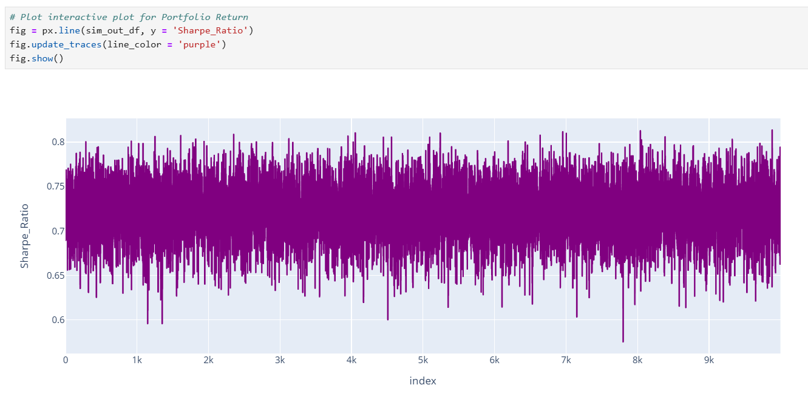

空值转换

print('====有NaN是true 否则是False===')

 #部分表格的数据是--表示，需要先转化为空，然后判断

# print(df1.isna())

print('将量比 字段中--强制转换为浮点类型NaN')

df1['量比'] = df1['量比'].replace('--', np.nan).astype(float)

print('返回空值的beelan索引 x')

x=df1.query('量比.isna()')

print(x)

liangbi_mean=df1['量比'].mean()

#iloc是整数索引 ，而 x.index是字符串索引，所以需要更换为 loc

df1.loc[x.index,'量比']=liangbi_mean

print(df1)

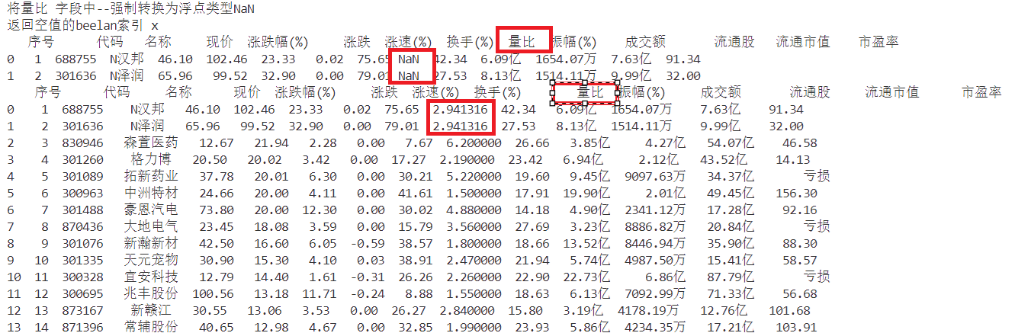

### Lesson 5.3 - Perform Data Visualization for a Single Stock: Part 1

Price return=P t-P(t-1)

The stock percentage daily return Rt indicates the percentage gain(or loss) for a given stock assuming that you bought the stock today and sold it the next day.

The percentage stock daily return is calculated using the following formula , where Pt is the price of the stock at day t(today) , Pt-1 is the price of the stock at day t-1 (yesterday)

Rt=(Pt-P(t-1))/p(t-1) * 100

Example :assume that you bought XYZ inc. Stock today at $100 per share. The price of tht stock increased to $110 the next day.

The percentage daily return is calculated as follows ：

Rt=(Pt-P(t-1))/P(t-1) * 100

=110-100/100 *100 =10%

Percentage Daily Returns in Python

Pandas.Pct_change()method calculates the percentage change between current and prior elements in a Pandas DataFrame.

# Calculate the percentage daily return

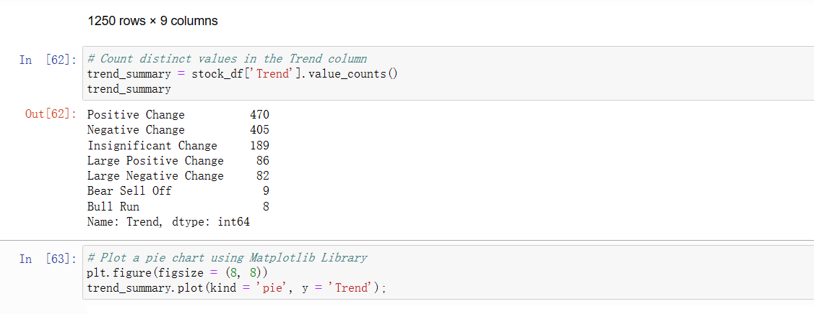

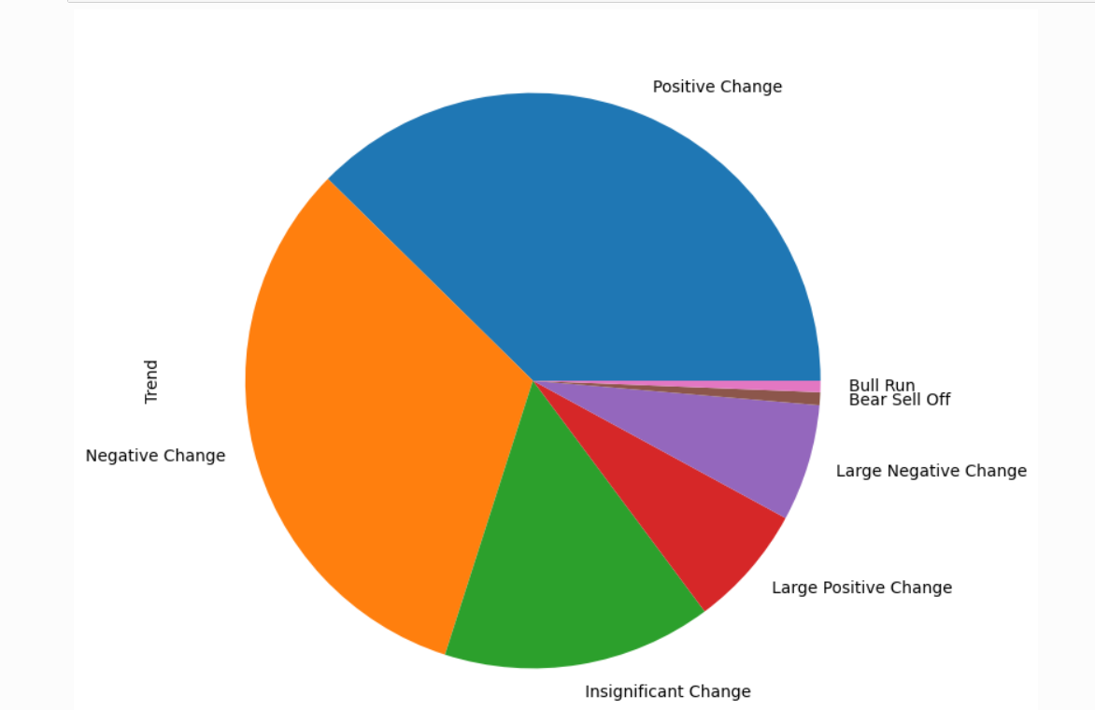

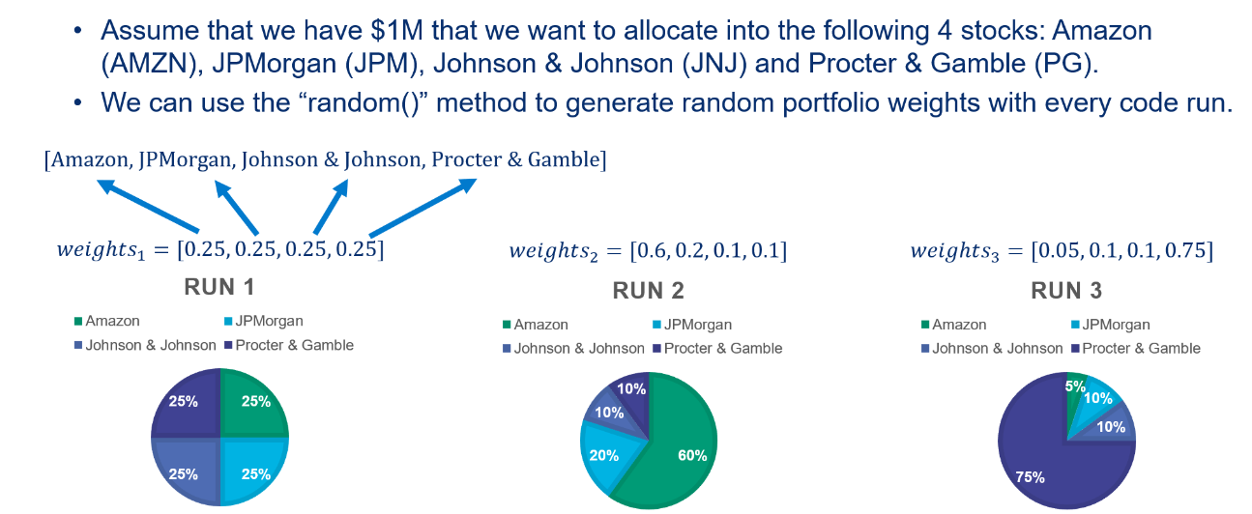

Assume we now have 10 stocks under consideration, test the function using the new number of stocks.

Perform a sanity check and ensure that the sum of all weights is equal to 1

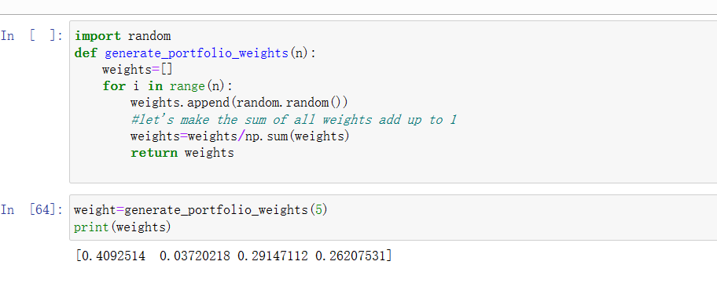

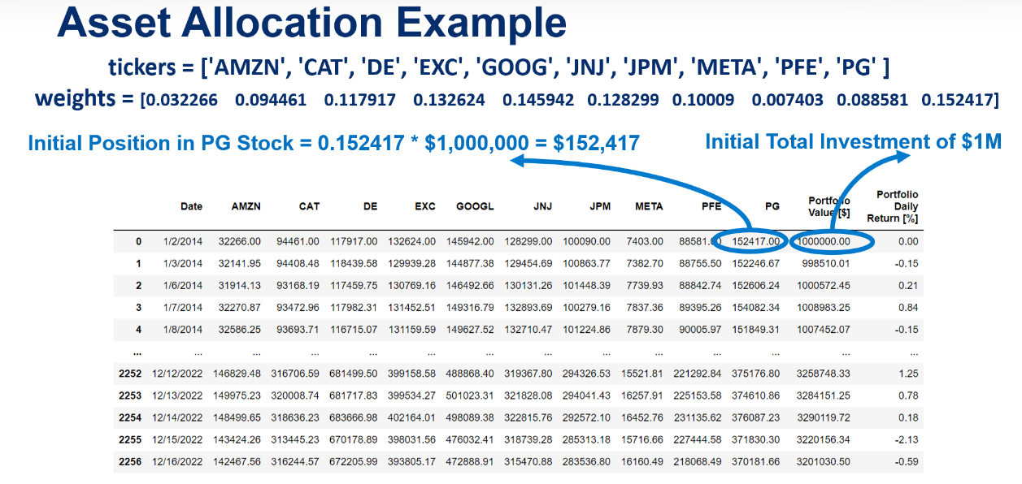

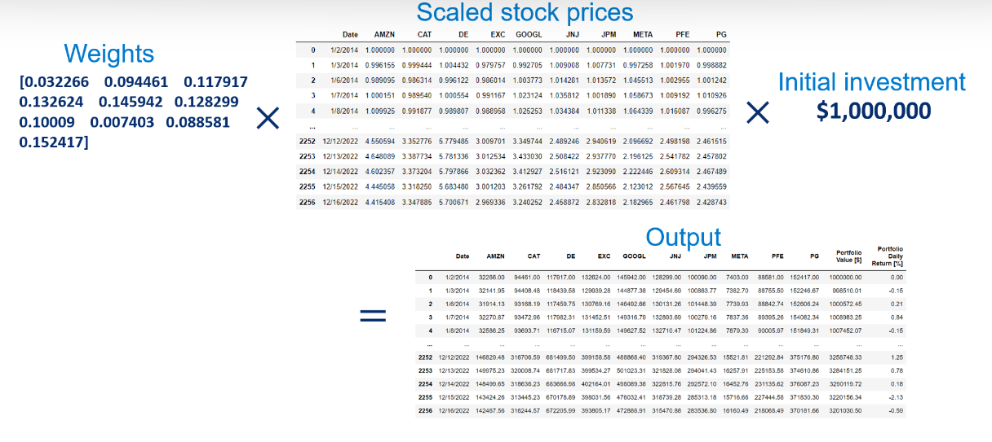

Code Overview

The enumerate() method returns the name of the stock in ‘stock’ variable along with a conuter

‘i’ this counter will be used to access elements in the ‘weights’ list.

For i stock in enumerate(scaled_df.columns[1:]):

Portfolio_df[stock]=weights[i]* scaled_df[stock] * initial_investment

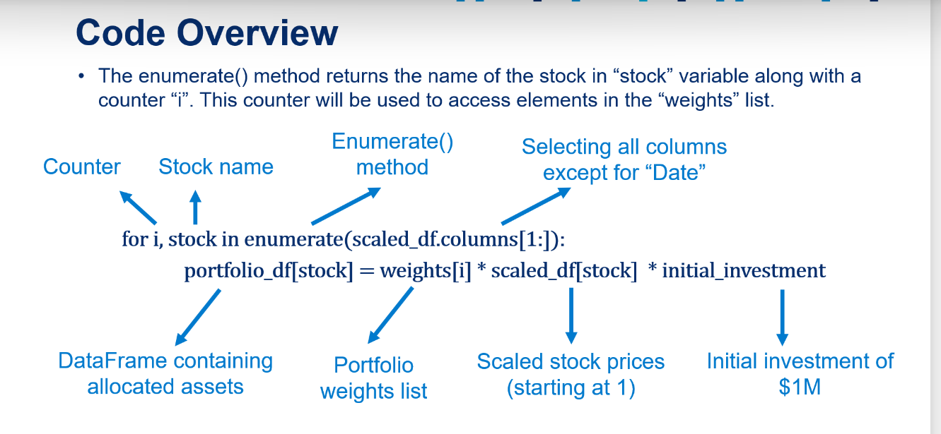

* ****Generate 3 different random weights and perform asset allocation using the pre-defined "asset_allocation" function.****
* ****Compare the final portfolio value on December 16th, 2022 to the initial investment ($1M) on January 2nd, 2014. Comment on your results.****
* *Hint: you will need to run the code 3 different times and examine the results. No additional code is required.*

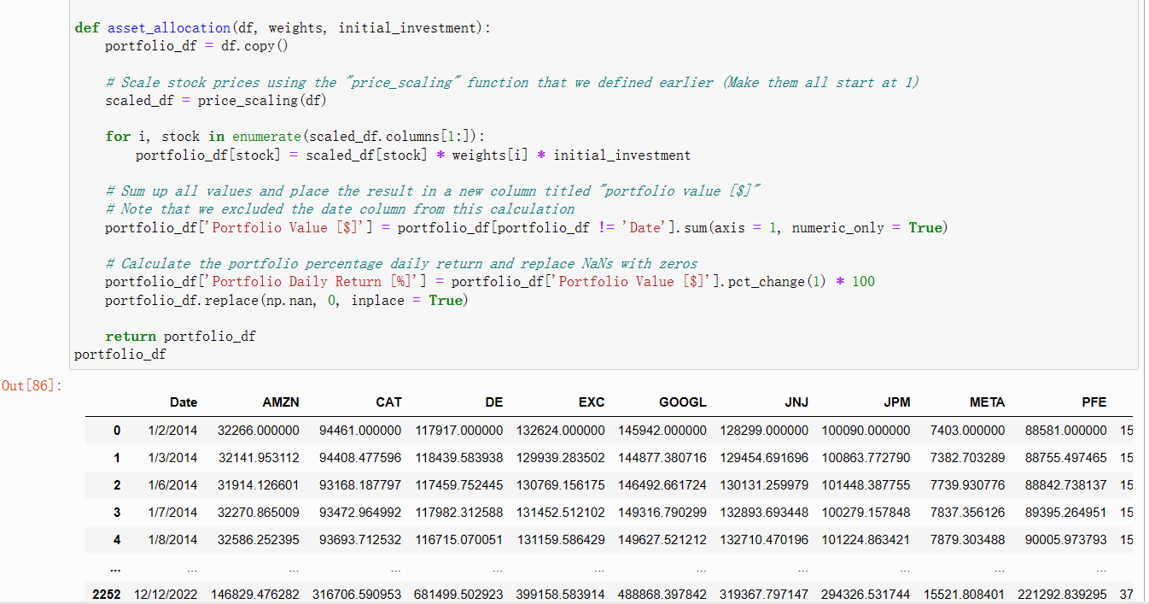

Define the “simulation” function that performs asset allocation

,and calculates key portfolio metrics Sharpe ratio Assume that you have two portfolio X and Y

Portfolio X expected annual return R(px)=15% standard deviation σ(px)=7%(higher risk)

Portfolio Y expected annual return R(py)=12% standard deviation σ(px)=4%(lower risk)

Sharpe ratio is calculated as follows (assuming Rf=3%)

Which one would you choose?

Portfolio X is a better choice solely based on return without considering risk

Sharpe ratio answers this question ....

Sharpe ratio is used to calculate the return of an investment compared to its risk and is calculated as follows:

Sharpe ratio=Rp-Rf/σp X : (15-3)/7=1.71 Y (12-3)/4=2.25

Where Rp: portfolio expected return

Rf risk free rate of rerurn (yield from a 10 years U.S government bond 3%)

σp :standard deviation of the portfolio(volatility)

Rp-Rf: market risk premium which is the excess return above risk-free rate

Sharpe ratio is simply a calculation of the average return earned in excess of the risk free rate per unit of risk (volatility)

As sharpe ratio increase ,risk adjusted return increase and security becomes more desirable by investors

* ****Assume that you decided to perform equal asset allocation among the 10 available stocks in "portfolio_df" DataFrame. Complete the following tasks:****
  + ****Define a new "weights" list that contains equal allocation among all assets.****
  + ****Call "simulation_engine" function and send it the new weights. Record the Sharpe ratio and portfolio final value.****
  + ****Assume that the risk-free rate is now set to 1%. How does that change impact Sharpe ratio? confirm your answer by changing the risk free-rate, running the code, and recording the new Sharpe ratio.****
* ****Monte Carlo Simulations****

Monte carlo simulation works by running several trials 几个试验with random inputs generated from an underlying distribution and observing the outcomes

It is applied in finance ,business, physics and game theory

In this project, we will use randomly generated portfolio weights as an input and observe portfolio return, risk and Sharpe ratio as the outputs.

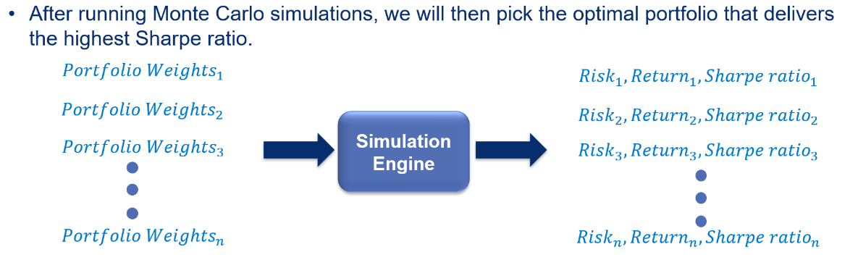

Using Cufflinks, plot a candlestick chart for JPMorgan Chase & Co. stock from 14 July 2017 to 16 December 2022. Remember to set the “Date” column as the index for the “JPM_df” pandas DataFrame.

Display the simple moving average with 30- and 100-day windows on the previously generated candlestick graph.

Display the Bollinger Bands on a new candlestick graph. Bollinger Bands is a powerful technical analysis tool that contains three lines:

(1) a simple moving average (middle band), (2) an upper band, and (3) a lower band. Choose a window length of 20 periods and two standard deviations. (External research is required.)

You can access the Coding Lab for this lesson by using the following link (it will open in a new tab so you can follow along with examples and do the practice opportunity):

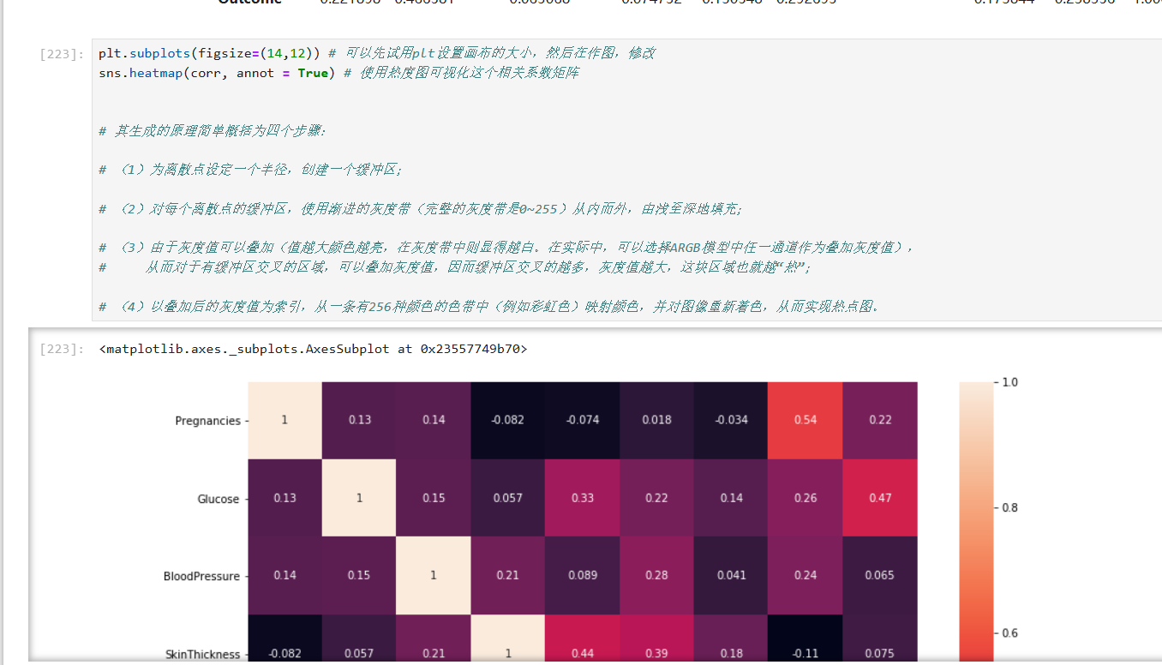

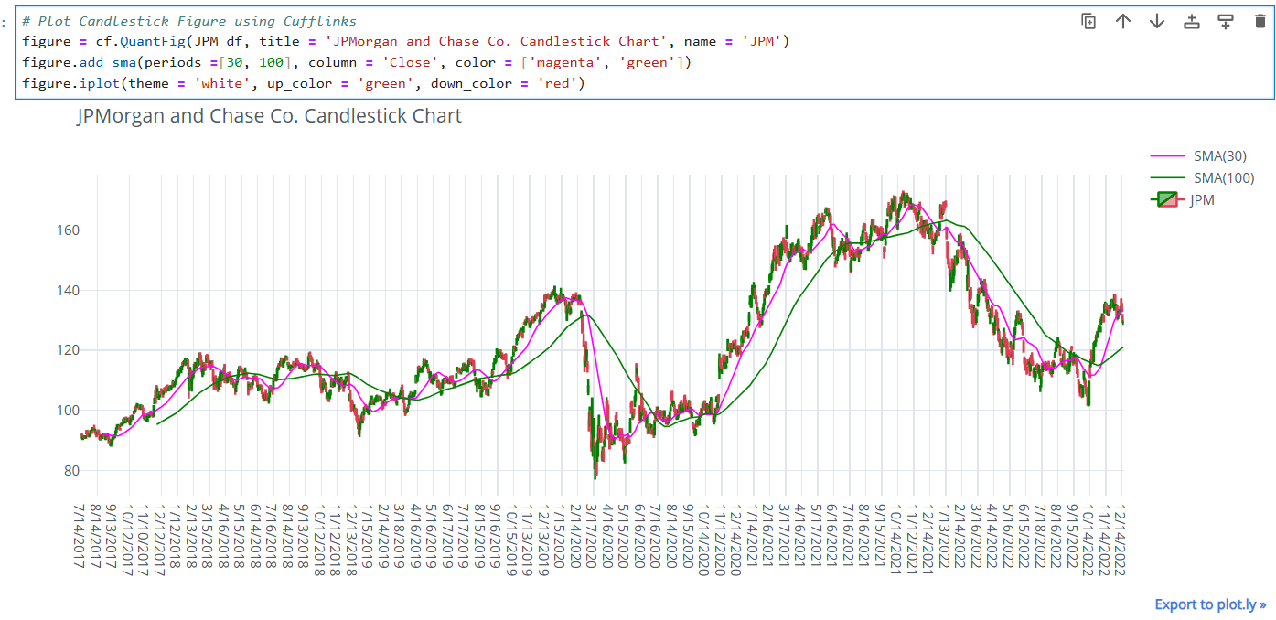

# Plot trading volume (Note that the position of the Volume column is different compared to Amazon's DataFrame)

plot_financial_data(JPM_df.iloc[:,[0,6]], 'JPMorgan Chase & Co. T**rading Volume')**

